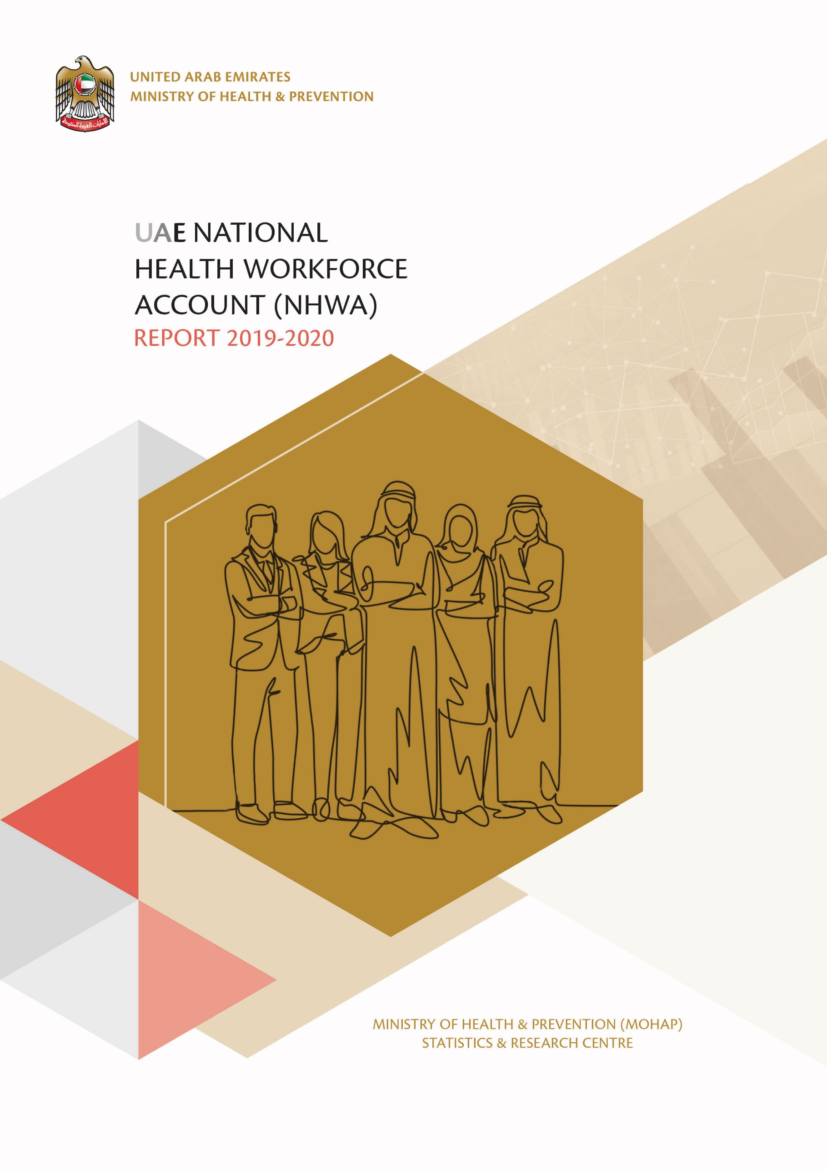

CONTRIBUTORS
- Ministry of Health & Prevention
- Ministry of Education
- Ministry of Education – Higher Education
- Ministry of Presidential Affairs
- Ministry of Human Resources & Emiratisation
- Commission for Academic Accreditation
- Dubai Health Authority
- Dubai Healthcare City
- Department of Health - Abu Dhabi
- Federal Authority for Government Human Resources
- Federal Competitiveness & Statistics Center
- World Health Organization

KEY INDIVIDUALS

AUTHOR

Varunendra Swarup Verma
Business Analyst
Statistics and Research Centre
Ministry of Health & Prevention

REVIEWERS

Dr. Alya Zaid Mohammed Harbi
Director
Statistics & Research Centre
Ministry of Health & Prevention
Dr. Tayba Mohammed Alawadi
Director
Health Services Planning and Health Economics
Ministry of Health & Prevention
Dr Mohammed Mustafa
Health Projects Expert
Health Services Planning and Health Economics
Ministry of Health & Prevention
Hend Ali Ibrahim Al Mulla
Head of Statistics Section
Statistics and Research Centre
Ministry of Health & Prevention

ACKNOWLEDGEMENT
We would like to express our sincere thanks and appreciation to all departments of the Ministry of Health and Prevention, esteemed Ministries and other Governmental and Private authorities, who contributed generously towards the collection and confirmation of the data in this report. Without their support and experience, this report would not have been possible.

FOREWORD
The Statistics and Research Centre (SARC) of MOHAP have prepared the report for the World Health Organization (WHO) devised National Health Workforce Account (NHWA) programme for UAE for the calendar year 2019 and 2020. Technical details of this entire programme can be viewed at https://www.who.int/hrh/documents/brief_nhwa_handbook/en/
This report contains information about the below areas of NHWA:
- Definition, characteristics and purpose behind implementation of this programme for UAE.
- Indicator values affecting health labour market cutting across education, labour workforce and population needs.
- Module wise detailed description and values of each indicator.
- Key comparisons of NHWA indicator values between UAE and other countries.
- MOHAP recommendations for addressing areas of concern with health workforce policies.
- Challenges faced by us during implementation.
The rationale behind presenting this report is for obtaining a holistic view of the UAE health workforce situation in terms of workforce statistics, skill and specialization adequacy, key policy regulations and information systems. We present the distinguishing aspects of UAE health workforce along with challenges and improvement areas, which when addressed, will catapult UAE’s health workforce to the greatest heights of population satisfaction and worker efficacy.
One of the limitations of this report is that we could not publish results for all of the NHWA indicators because those data items were not available with the identified stakeholders. This has been highlighted in the chapter 16 relating to Challenges with NHWA implementation. We are highly optimistic that these pending areas shall be addressed in the subsequent NHWA edition.

ABBREVIATIONS & ACRONYMS

Abbreviation | Full Form
CPD | Continuing Professional Development
DHA | Dubai Health Authority
DHCC | Dubai Health Care City
DOH | Department of Health – Abu Dhabi
FAHR | Federal Authority for Government Human Resources
FCSC | Federal Competitiveness and Statistics Center
HIS | Health Information System
HRHIS | Human Resource for Health Information System
HWF | Health Workforce
IHR | International Health Regulation
IPE | Inter-professional Education
MOE | Ministry of Education
MOE – HE | Ministry of Education – Higher Education
MOHAP | Ministry of Health & Prevention
MOHRE | Ministry of Human Resources & Emiratisation
SDG | Sustainable Development Growth
UHC | Universal Health Coverage
WHO | World Health Organization

TABLE OF CONTENTS
1. CONTRIBUTORS 1
2. KEY INDIVIDUALS 2
2.1 AUTHOR 2
2.2 REVIEWERS 2
3. ACKNOWLEDGEMENT 3
4. FOREWORD 4
5. ABBREVIATIONS & ACRONYMS 5
6. TABLE OF CONTENTS 6
7. LIST OF FIGURES 10
8. LIST OF TABLES 11
9. CHAPTER 1: INTRODUCTION TO NATIONAL HEALTH WORKFORCE ACCOUNT 12
9.1 Definition 12
9.2 Characteristics 12
9.3 Purpose 12
9.4 Benefits 13
10. CHAPTER 2: NHWA MODULES 14
11. CHAPTER 3: NHWA UAE INDICATORS VALUES 15
12. CHAPTER 4: MODULE 1 – ACTIVE HEALTH WORKFORCE STOCK 20
12.1 Key Areas 20
12.2 Indicator Data 21
12.3 Auxiliary Information 28
12.3.1 Covid-19 Impact on Health Workers (2020) 28
12.4 Module Summary 29
12.4.1 Active Health Workforce Stock – Key Facts 29
13. CHAPTER 5: MODULE 2 – EDUCATION & TRAINING 30
13.1 Key Areas 30
13.2 Indicator Data 31
13.3 Auxiliary Information 34
13.3.1 Education and Training - Data (2019) 34
13.3.2 Education and Training – Data (2020) 34
13.4 Module Summary 35
13.4.1 Education & Training – Key Facts 35
14. CHAPTER 6: MODULE 3 - EDUCATION & TRAINING REGULATION AND ACCREDITATION 36
14.1 Key Areas 36
14.2 Indicator Data 37
14.3 Module Summary 46
14.3.1 Education and Training - Regulation and Accreditation - Key Facts (2019,2020) 46
15. CHAPTER 7: MODULE 4 – EDUCATION FINANCES 47
15.1 Key Areas 47
15.2 Indicator Data 48
15.3 Module Summary 49
15.3.1 Education Finances - Key Facts 49
16. CHAPTER 8: MODULE 5 – HEALTH LABOUR MARKET FLOWS 50
16.1 Key Areas 50
16.2 Indicator Data 51
16.3 Auxiliary Information 52
16.3.1 Healthcare Private Sector Job Vacancies – Data 52
16.4 Module Summary 52
16.4.1 Health Labour Market Flows - Key Facts 52
17. CHAPTER 9: MODULE 6 – EMPLOYMENT CHARACTERISTICS AND WORKING CONDITIONS 53
17.1 Key Areas 53
17.2 Indicator Data 54
17.3 Module Summary 61
17.3.1 Employment Characteristics & Working Conditions - Key Facts 61
18. CHAPTER 10: MODULE 7 - HEALTH WORKFORCE SPENDING & REMUNERATION 62
18.1 Key Areas 62
18.2 Indicator Data 63
18.3 Module Summary 63
18.3.1 Health Workforce Expenditure and Remuneration – Key Facts 63
19. CHAPTER 11: MODULE 8 - SKILL-MIX COMPOSITION FOR MODELS OF CARE 64
19.1 Key Areas 64
19.2 Indicator Data 65
19.3 Module Summary 72
19.3.1 Skill-mix composition for models of care – Key Facts 72
20. CHAPTER 12: MODULE 9 - GOVERNANCE AND HEALTH WORKFORCE POLICIES 73
20.1 Key Areas 73
20.2 Indicator Data 74
20.3 Module Summary 78
20.3.1 Governance and Health Workforce Policies – Key Facts 78
21. CHAPTER 13: MODULE 10 – HEALTH WORKFORCE INFORMATION SYSTEMS 79
21.1 Key Areas 79
21.2 Indicator Data 80
21.3 Module Summary 86
21.3.1 Health workforce Information Systems – Key Facts 86
22. CHAPTER 14: NHWA INTERNATIONAL COMPARISONS 87
22.1 Overview 87
22.2 Gender Distribution Indicator 87
22.2.1 Medical Doctor 87
22.2.2 Nursing 88
22.3 Category-wise Health Worker Density indicator 88
22.3.1 Medical Doctor per 10 000 population 88
22.3.2 Nurses and Midwifery per 10 000 population 89
22.3.3 Dentists per 10 000 population 89
22.3.4 Pharmacists per 10 000 population 90
23. CHAPTER 15: MOHAP RECOMMENDATIONS 91
23.1 Capability Indicator Status 91
23.2 MOHAP Recommendations 92
23.2.1 Recommendation for Accreditation of non-compulsory education and training institutions 92
23.2.2 Recommendation for implementation of accreditation standards for IPE 93
23.2.3 Recommendation for integration of CPD into National Education Plan 94
23.2.4 Recommendation for Regulation on Minimum Wage 95
23.2.5 Recommendation for Regulation on Social Protection 96
23.2.6 Recommendation for Regulation on Dual Practise 97
23.2.7 Recommendation for capacity of Field Epidemiology Training Programmes 98
23.2.8 Recommendation for reporting capabilities of HRHIS for IHR 99
23.2.9 Recommendation for reporting capabilities of HRHIS for WHO Code of Practise reporting 100
23.2.10 Recommendation for HRHIS in reporting on outputs from education and training institutions 101
23.2.11 Recommendation for HRHIS production of geocoded health facility locations 102
24. CHAPTER 16: CHALLENGES 103
24.1 General Challenges 103
24.2 Challenges in NHWA Data Collection 104
24.2.1 Module 1 – Active Health Workforce Stock 104
24.2.2 Module 2 – Education & Training 105
24.2.3 Module 4 – Education Finances 106
24.2.4 Module 5 – Health Labour Market Flows 107
24.2.5 Module 6 – Employment Characteristics and Working Conditions 109
24.2.6 Module 7 – Health Workforce Expenditure 110
25. Glossary 111

LIST OF FIGURES
Figure 1 - NHWA Purpose 12
Figure 2 - NHWA Benefits 13
Figure 3 - NHWA Modules 14
Figure 4 - Module 1 Key Areas 20
Figure 5 - Category-wise Manpower UAE chart 22
Figure 6 - Gender-wise Manpower chart 25
Figure 7 - UAE 2020 Health Workforce Covid-19 Impact 28
Figure 8 - Module 2 Key Areas 30
Figure 9 - Module 3 Key Areas 36
Figure 10 - Module 4 Key Areas 47
Figure 11 - Module 5 Key Areas 50
Figure 12 - Module 6 Key Areas 53
Figure 13 - Module 7 Key Areas 62
Figure 14 - Module 8 Key Area 64
Figure 15 - Module 9 Key Areas 73
Figure 16 - Module 10 Key Areas 79
Figure 17 - Medical Doctor - Global Gender Comparison 87
Figure 18 - Nurses - Global Gender Comparison 88
Figure 19 - Global Medical Doctor densities 88
Figure 20 - Global Nurse and Midwife Density 89
Figure 21 - Global Dentists Density 89
Figure 22 - Global Pharmacist Density 90
Figure 23 - Steps for accreditation of IPE 93
Figure 24 - CPD Inclusion process in National Education Plan 94
Figure 25 - IHR Framework 99

LIST OF TABLES
Table 1 - NHWA UAE Core Indicator values 19
Table 2 - Category-wise Manpower Summary 22
Table 3 - Gender-wise Manpower Summary 25
Table 4 - Module Summary - Active Health Workforce Stock 29
Table 5 - Higher Education Course Training Duration 33
Table 6 - Module Summary - Education and Training 35
Table 7 - Module Summary - Education and Training Regulation and Accreditation 46
Table 8 - Module Summary - Education Finances 49
Table 9 - Private Sector Vacancies 52
Table 10 - Module Summary - Health Labour Market Flows 52
Table 11 - Self Employed Workforce 58
Table 12 - Module Summary - Employment Characteristics and Working Conditions 61
Table 13 - Module Summary - Skill-mix composition for models of care 72
Table 14 - Module Summary - Governance and health workforce policies 78
Table 15 - Module Summary - Health workforce information systems 86
Table 16 - Capability Indicator Status 91

CHAPTER 1: INTRODUCTION TO NATIONAL HEALTH WORKFORCE ACCOUNT

Definition
The National Health Workforce Account (NHWA) is a system developed under the direction of the World Health Organization (WHO) Health Workforce Department using which countries can collect evidence-based data pertaining to the health workforce, which is progressively monitored using a set of indicators. The health workforce data collected encompasses areas such as health workforce stock and distribution, education and training - capacity, regulations and finances, employment characteristics and working conditions, workforce expenditure and remuneration, skill-mix distribution, governance & policies and human resource information systems.

Characteristics
The NHWA is a data-intensive programme which has the below mentioned characteristics:
- Provides a harmonized and integrated method for health workforce data collection.
- Technically defines a set of indicators for precise data acquisition and analysis.
- Promotes a multi-stakeholder synergistic environment for holistic data generation.
- Improves the interoperability of health information systems spread across multiple public and private entities.
- Creates an official platform for secure dissemination of health workforce indicator data.

Purpose
The primary purpose of the NHWA programme is to facilitate the standardization and interoperability of health workforce data and track performance towards Universal Health Coverage (UHC).
The health workforce indicator data is collected, reconciled, analyzed, verified and reported in order to meet below objectives:
Figure 1 - NHWA Purpose

The implementation of NHWA programme shall serve following purposes for UAE:
- Achieve the Universal Health Coverage and Sustainable Development Goals milestones.
- First country to report on all NHWA modules.
- Provide best in class services and attain top global leadership in healthcare.
- Achieve holistic development of healthcare education and systems.
- Better planning for dealing with increasing healthcare demand.

Benefits
The implementation of NHWA provides benefits global, national and regional levels.

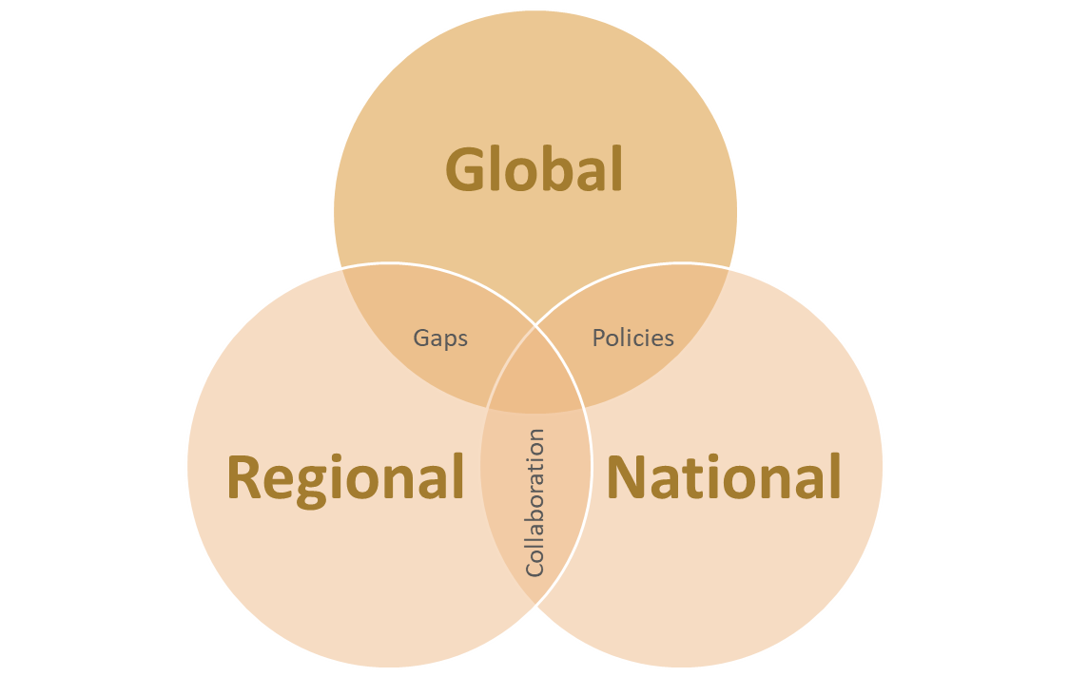
Figure 2 - NHWA Benefits

At Global level, NHWA implementation results in below benefits:
- Formulation of evidence-based health workforce plans and policies.
- Data Standardization and interoperability.
- Establishment of a benchmark for health workforce data standards.
- Facilitation of standardized data comparisons against other countries.
At National Level, NHWA implementation results in below benefits:
- Review of National health workforce data.
- Identification of gaps, shortages and mismatches in health workforce data.
- Assessment of existing policies and plans that impact the health workforce.
- Strengthened multi-stakeholder collaboration resulting in creation of inter-sectoral policies, strategies and plans.

At Regional Level, NHWA Implementation results in below benefits:
- Accurate capture of region level health workforce data.
- Facilitation of cross-country capacity building, information and data exchange.
- Aid in sophisticated research about future trends of health workforces regionally.

CHAPTER 2: NHWA MODULES

The NHWA contains a set of 78 core indicators, spread over 10 modules that aim to support national-level HWF policies to progress towards UHC and SDGs. The indicators in the 10 modules feed into three crucial labour market components: the education component, the labour force component and the component serving population health needs.
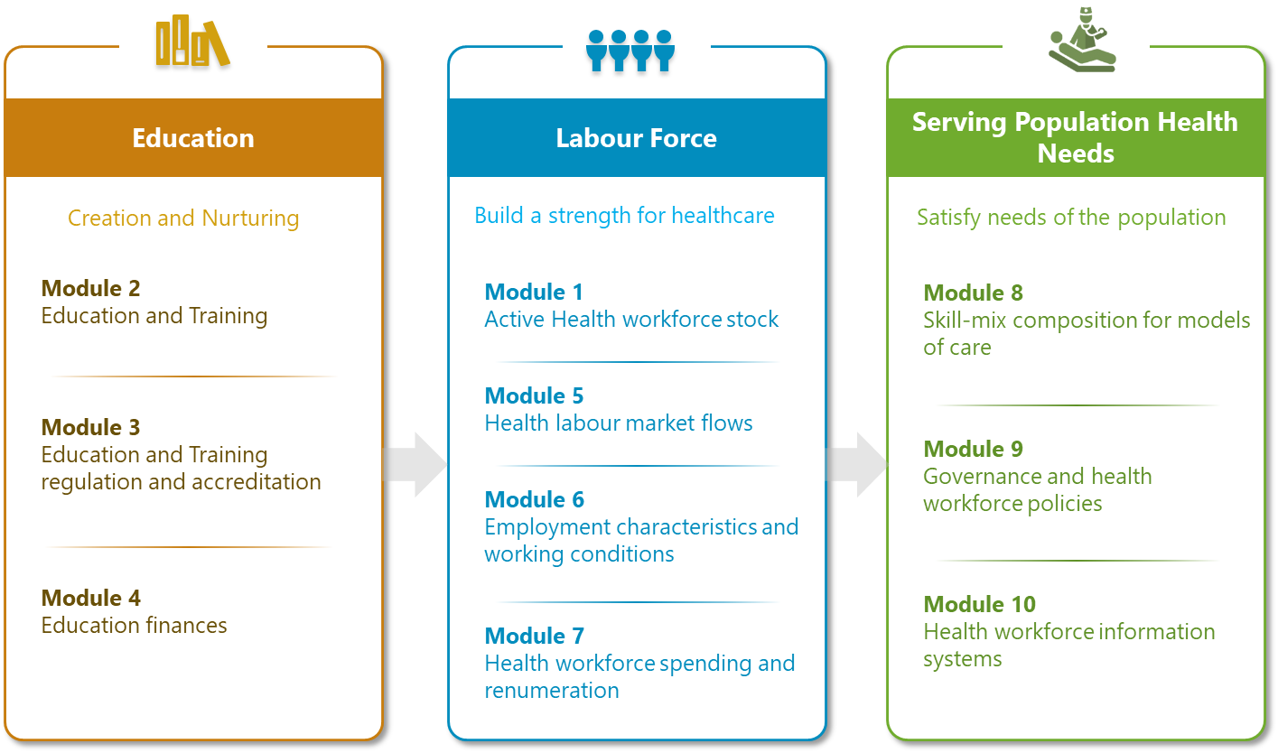
Figure 3 - NHWA Modules

CHAPTER 3: NHWA UAE INDICATORS VALUES

Indicator Id | Unique Reference Id | Indicator Title | 2019 Value | 2020 Value | Data Source
1.01 | ID_169 | Health worker density | 132  (per 10 000 population) | 142.11  (per 10 000 population) | DOH  DHA  DHCC  MOPA  MOHAP
1.03 | ID_171 | Health worker distribution by age group | <25 : 0.60  25–34 : 41.84  35–44 : 39.98  45–54 : 11.68  55–64 : 4.39  >=65 : 1.5  Percent (%) | <25 : 1.14  25–34 : 42.77  35–44 : 33.00  45–54 : 16.01  55–64 : 5.60  >=65 : 1.48  Percent (%) | Same as above
1.04 | ID_172 | Female health workforce | 64.21  Percent (%) | 64.00  Percent (%) | Same as above
1.05 | ID_173 | Health worker distribution by facility ownership | Public : 34.16  Private : 65.84  Percent (%) | Public : 35.31  Private : 64.69  Percent (%) | Same as above
1.06 | ID_174 | Health worker distribution by facility type | Hospitals : 44.39  Ambulatory : 34.20 Retail : 9.36  Govt. Admin : 4.75 Others : 4.32  Ancillary : 1.61  Residential : 1.37  Percent (%) | Hospitals : 44.82 Ambulatory : 34.10  Retail : 9.75  Others : 4.61  Govt. Admin : 3.20  Residential : 1.82  Ancillary : 1.69  Percent (%) | Same as above
2.01 | ID_178 | Master list of accredited health workforce education and training institutions | Yes | Yes | MOE
2.02 | ID_179 | Duration of education and training | General Practitioner  Bachelors - 5 (Years)  Specialist Practitioner  Doctorate - 3 (Years)  Dentist  Masters - 3 (Years)  Pharmacist  Masters - 2 (Years)  Nursing Professional  Masters - 1.5 (Years) | General Practitioner  Bachelors - 5 (Years)  Specialist Practitioner  Doctorate - 3 (Years)  Dentist  Masters - 3 (Years)  Pharmacist  Masters - 2 (Years)  Nursing Professional  Masters - 1.5 (Years) | Same as above
3.01 | ID_185 | Standards for the duration and content of education and training | Yes | Yes | Done
3.02 | ID_186 | Accreditation mechanisms for education and training institutions and their programmes | Partly | Partly | CAA
3.03 | ID_187 | Standards for social accountability | Yes | Yes | CAA
3.04 | ID_188 | Standards for social accountability effectively implemented | Yes | Yes | CAA
3.05 | ID_189 | Existence of national and/or subnational standards for the social determinants of health in accreditation mechanisms | Yes | Yes | CAA
3.06 | ID_190 | Standards for interprofessional education | Partly | Partly | CAA
3.07 | ID_191 | Agreement on accreditation standards | Yes | Yes | CAA
3.08 | ID_192 | Continuing professional development | Partly | Partly | MOHAP
3.09 | ID_193 | In-service training | Yes | Yes | CAA
4.01 | ID_194 | Total expenditure on higher education | 10,170,878,477.65  (AED per year) | 8,744,672,232.00  (AED per year) | MOE
4.08 | ID_201 | Total expenditure on in-service training and continuing professional development | 25,696,495.75  (AED per year) | 21,541,950  (AED per year) | MOE
5.06 | ID_207 | Unemployment Rate | 4.9  Percent (%) | Not Reported | FCSA
6.01 | ID_209 | Standard working hours | 48  (Hours per 6 days) | 48  (Hours per 6 days) | MOHAP
6.03 | ID_211 | Regulation on working hours and conditions | Yes | Yes | DHA  FAHR  MOHRE
6.04 | ID_212 | Regulation on minimum wage | Partly | Partly | DHA  FAHR  MOHRE
6.05 | ID_213 | Regulation on social protection | Partly | Partly | DHA  FAHR  MOHRE
6.06 | ID_214 | Health worker status in employment | 0.75  Percent (%) | 0.78  Percent (%) | MOHRE
6.07 | ID_215 | Regulation on dual practice | Partly | Partly | DHA  MOHRE
6.09 | ID_217 | Measures to prevent attacks on health workers | Yes | Yes | DHA  MOHRE
7.06 | ID_224 | Policies on public sector wage ceilings | Yes | Yes | MOHAP
8.01 | ID_226 | Percentage of health workforce working in hospitals | 44.39  Percent (%) | 44.82  Percent (%) | DOH  DHA  DHCC  MOPA  MOHAP
8.02 | ID_227 | Percentage of health workforce working in residential long-term care facilities | 1.37  Percent (%) | 1.82  Percent (%) | Same as above
8.03 | ID_228 | Percentage of health workforce working in ambulatory health care | 34.20  Percent (%) | 34.10  Percent (%) | Same as above
8.04 | ID_229 | Specialist surgical workforce | 70.43  (per 100 000 population) | 68.90  (per 100 000 population) | UAE Level
8.06 | ID_231 | Existence of advanced nursing roles | Yes | Yes | MOHAP
8.07 | ID_232 | Availability of human resources to implement the International Health Regulations | Sustainable Capacity | Sustainable Capacity | MOHAP
8.08 | ID_233 | Applied epidemiology training programme | Limited  Capacity | Limited  Capacity | MOHAP
9.01 | ID_234 | Mechanisms to coordinate an intersectoral health workforce agenda | Yes | Yes | MOHAP
9.02 | ID_235 | Central health workforce unit | Yes | Yes | MOHAP
9.03 | ID_236 | Health workforce planning processes | Yes | Yes | MOHAP
9.04 | ID_237 | Education plans aligned with national health plan | Yes | Yes | MOHAP
9.05 | ID_238 | Institutional models for assessing  health care staffing needs | Yes | Yes | MOHAP
10.01 | ID_239 | HRHIS for reporting on International Health Regulations | No | No | MOHAP
10.02 | ID_240 | HRHIS for WHO Code of Practice reporting | Partly | Partly | MOHAP
10.04 | ID_242 | HRHIS for reporting on outputs from education and training institutions | No | No | MOHAP
10.05 | ID_243 | HRHIS for tracking the number of entrants to the labour market | Yes | Yes | MOHAP
10.06 | ID_244 | HRHIS for tracking the number of active stock on the labour market | Yes | Yes | MOHAP
10.07 | ID_245 | HRHIS for tracking the number of exits from the labour market | Yes | Yes | MOHAP
10.08 | ID_246 | HRHIS for producing the geocoded location of health facilities | Partly | Partly | MOHAP
Table 1 - NHWA UAE Core Indicator values

CHAPTER 4: MODULE 1 – ACTIVE HEALTH WORKFORCE STOCK

Overview: This module provides a detailed overview of the below aspects of health workforce:
- Stock – The total health workforce within the country as well as within all regions of the country in comparison to total population. This data enables ascertaining adequacy of health workforce for delivering UHC-oriented services.
- Distribution – The bifurcation of health workforce across gender and various age groups. The distribution of health workforce based on employment in different types of facilities and facilities ownership. This data enables gap detection in certain occupational sectors and highlights mismatches in geographical or sectoral distribution.
- Migration – Focus on quantity of foreign-born and foreign-trained workers in a country thereby revealing amount of reliance on foreign health workforce. This data will assist countries in meeting the GSHRH target of halving dependency on foreign-trained health workers through implementation of WHO Global Code of Practise.
Kindly Note - We have not received data for few indicators of this module. Details are present in section: ‎24.2.1 Module 1 – Active Health Workforce Stock

Key Areas
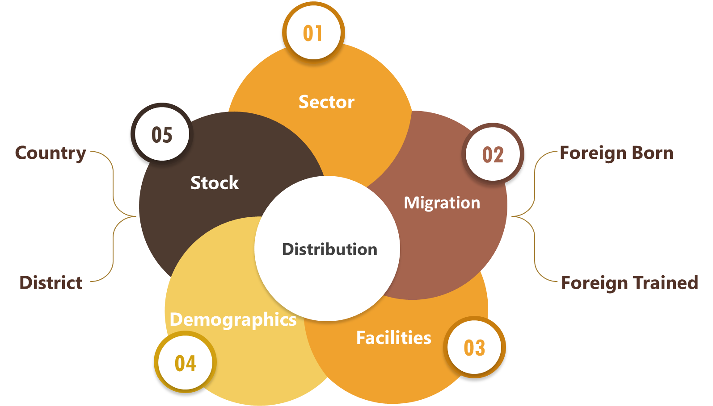
Figure 4 - Module 1 Key Areas

Indicator Data
Indicator Id | 1.01
Unique Reference Id | ID_169
Name | Health worker density
Definition | Number of health workers per 10 000 population inclusive of Medical Doctors, Dentists, Nurses, Pharmacists and Technicians.
Numerator | Number of health workers, defined in headcounts
Denominator | Total population
Value | 132 (2019) 142.11 (2020)
Unit | Per 10 000 population
Level | UAE
Comments | 2020 Health Workforce Density includes additional Health Workers recruited in 2020 specially for COVID-19.
Data Sources | Department of Health (DOH)  Dubai Health Authority (DHA)  Dubai Healthcare City (DHCC)  Ministry of Health and Prevention (MOHAP)  Ministry of Presidential Affairs (MOPA)
Related Facts | - Manpower is the common terminology used in the UAE in relation to Health Workforce data.  - Above data has been chiefly derived and aggregated from the Licensing Systems of the mentioned data sources.  - The Ministry of Health & Prevention (MOHAP) presents its health workforce data based on 2 systems; namely BAYANATI (HRHIS system for all Federal Ministries) and Licensing System.  - Any Administrative/Managerial worker data has been excluded in the density.

Figure 5 - Category-wise Manpower UAE chart
Category | 2019 |  | 2020 |  |  | Increase%  Year On Year
 | Total | Per 10 000 population |  | Total | Per 10 000 population
Medical Doctors | 25414 | 27 |  | 26736 | 28.80 | 5.20
Dentists | 6576 | 7 |  | 6860 | 7.39 | 4.32
Pharmacists | 11827 | 12 |  | 11153 | 12.02 | -5.70
Nurses | 56142 | 59 |  | 59043 | 63.61 | 5.17
Technicians | 25928 | 27 |  | 28124 | 30.30 | 8.47
Total | 125887 | 132 |  | 131916 | 142.11 | 4.79
Table 2 - Category-wise Manpower Summary

Indicator Id | 1.03
Unique Reference Id | ID_171
Name | Health worker distribution by age group
Definition | Percentage of health workers in different age groups as mentioned below:  - <25  - 25–34  - 35–44  - 45–54  - 55–64  - >=65
Numerator | Number of health workers in a specific age group
Denominator | Total number of health workers, defined in headcounts
Value | (2019)  - <25 : 0.60  - 25–34 : 41.84  - 35–44 : 39.98  - 45–54 : 11.68  - 55–64 : 4.39  - >= 65 : 1.50 | (2020)  - <25 : 1.14  - 25–34 : 42.77  - 35–44 : 33.00  - 45–54 : 16.01  - 55–64 : 5.60  - >= 65 : 1.48
Unit | Percent (%)
Level | UAE
Data Sources | Department of Health (DOH)  Dubai Health Authority (DHA)  Dubai Healthcare City (DHCC)  Ministry of Health and Prevention (MOHAP)  Ministry of Presidential Affairs (MOPA)

Indicator Id | 1.04
Unique Reference Id | ID_172
Name | Female health workforce
Definition | Percentage of female health workers in health workforce.
Numerator | Number of female health workers
Denominator | Total number of male and female health workers, defined in headcounts
Value | 64.21 (2019) 64.00 (2020)
Unit | Percent (%)
Level | UAE
Data Sources | Department of Health (DOH)  Dubai Health Authority (DHA)  Dubai Healthcare City (DHCC)  Ministry of Health and Prevention (MOHAP)  Ministry of Presidential Affairs (MOPA)

Figure 6 - Gender-wise Manpower chart
Category | 2019 |  | 2020
 | Male | Female | Male | Female
Medical Doctors | 14816 | 10598 | 15254 | 11482
Dentists | 3112 | 3464 | 3226 | 3634
Pharmacists | 5959 | 5868 | 5518 | 5635
Nurses | 10371 | 45771 | 12192 | 46851
Technicians | 10793 | 15135 | 11862 | 16262
Total | 45051 | 80836 | 48052 | 83864
Table 3 - Gender-wise Manpower Summary

Indicator Id | 1.05
Unique Reference Id | ID_173
Name | Health worker distribution by facility ownership
Definition | Percentage of health workers employed by type of facility ownership.
Numerator | Number of health workers, defined in headcounts, working in facilities owned by the given institutional sector
Denominator | Total number of health workers, defined in headcounts
Value | (2019)  Public : 34.16  Private: 65.84 | (2020)  Public : 35.31  Private: 64.69
Unit | Percent (%)
Level | UAE
Data Sources | Department of Health (DOH)  Dubai Health Authority (DHA)  Dubai Healthcare City (DHCC)  Ministry of Health and Prevention (MOHAP)  Ministry of Presidential Affairs (MOPA)

Indicator Id | 1.06
Unique Reference Id | ID_174
Name | Health worker distribution by facility type
Definition | Percentage of health workers employed by facility type.
Numerator | Number of health workers, defined in headcounts, working in a specific facility type
Denominator | Total number of health workers, defined in headcounts
Value | Hospitals  Ambulatory Facilities  Retailers  Govt. Administration  Others  Ancillary Services  Residential Care | (2019)  44.39  34.20  9.36  4.75  4.32  1.61  1.37 | (2020)  44.82  34.10  9.75  3.20  4.61  1.69  1.82
Unit | Percent (%)
Level | UAE
Data Sources | Department of Health (DOH)  Dubai Health Authority (DHA)  Dubai Healthcare City (DHCC)  Ministry of Health and Prevention (MOHAP)  Ministry of Presidential Affairs (MOPA)

Auxiliary Information

Covid-19 Impact on Health Workers (2020)
Any report on healthcare statistics in the year 2020 would be incomplete without the mention of the infamous and devastating COVID-19 pandemic which remains very much rampant and active during the time of the publishing of this report. We wish to highlight few key impacts of the COVID-19 on the health workforce of UAE.
Multiple holistic initiatives were undertaken by UAE Government to combat the COVID-19 Pandemic

Special attention was placed towards the support, recognition and safety of Frontline Health Workers

Additional Health Workforce were specially recruited in 2020 for support & mitigation

This ensured Health Workforce adequacy to successfully respond to all COVID-19 challenges.

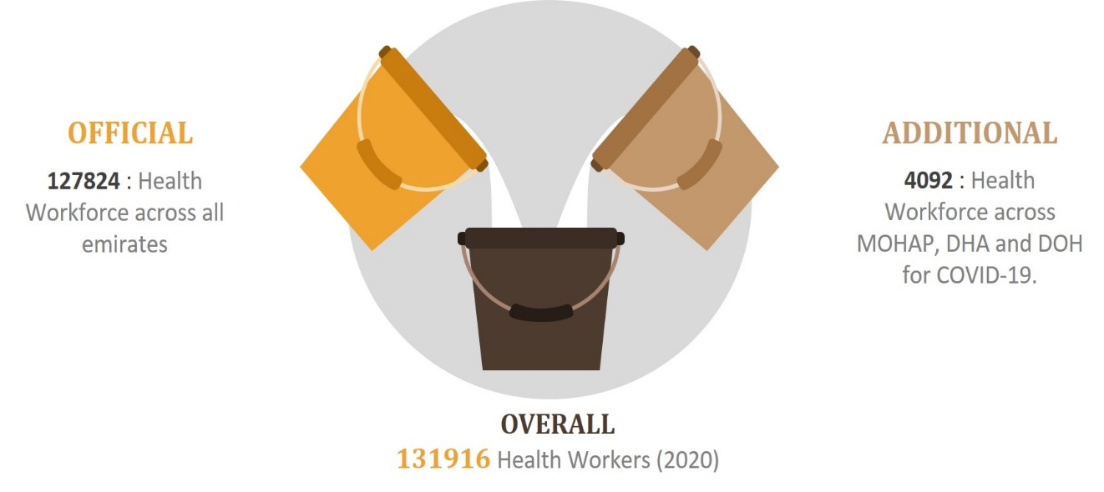
Figure 7 - UAE 2020 Health Workforce Covid-19 Impact

Module Summary

Active Health Workforce Stock – Key Facts
- UAE Health Worker Density : 132(2019) and 142.11 (2020) is well above the WHO
specified minimum threshold of 44.5.
- Gender Distribution : >60% of health workforce is Female working across Nursing
Specialty.
- Sector Distribution : >60% of health workforce work in Private Healthcare Sector.
- Facility Distribution : >40% of health workforce stationed in Hospital facilities.
- Age Distribution : >40% of health workforce belonging to age group 25-34 years.
Table 4 - Module Summary - Active Health Workforce Stock

CHAPTER 5: MODULE 2 – EDUCATION & TRAINING

Overview: This module addresses capacity, quality and gender equality in health workforce education and training along with graduation success rate. The benefits of data acquired in this module includes below key areas:
- Enables planning and monitoring for policies related to:
  - Student Selection
  - Admissions
  - Enrolments
  - Teaching staff
- Creates pool of qualified health workers based on successful graduation
Kindly Note - We have not received data for majority of the indicators of this module. Details are present in section: ‎24.2.2 Module 2 – Education & Training

Key Areas
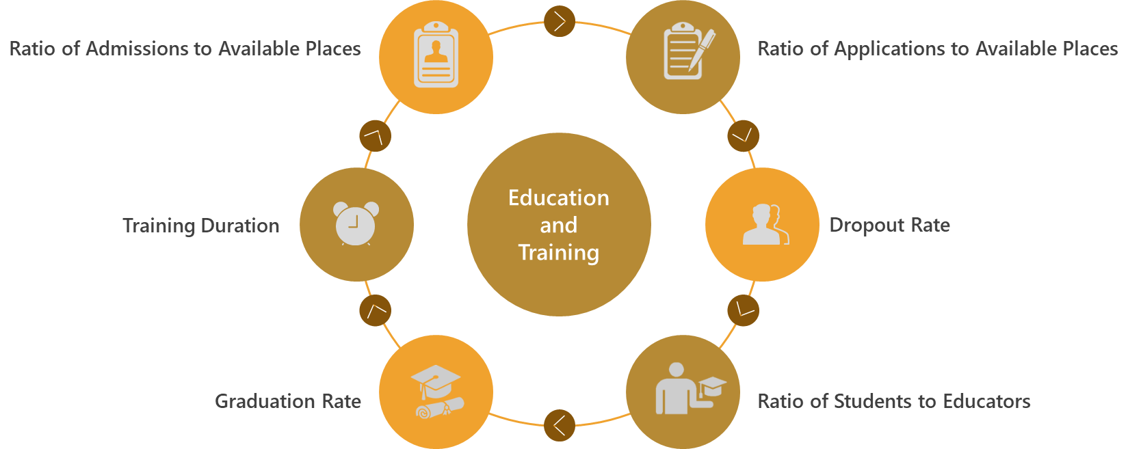
Figure 8 - Module 2 Key Areas

Indicator Data
Indicator Id | 2.01
Unique Reference Id | ID_178
Name | Master list of accredited health workforce education and training institutions
Possible Values | Yes/No/Partly
Definition | Existence of a master list of accredited health workforce education and training institutions that is up to date and available in the public domain.
Value | Yes (2019) Yes (2020)
Level | UAE
Comments | List of MOE licensed higher health universities present in below table.
Data Source | Ministry of Education (MOE)
Related Facts | - There is a National Admissions & Placement Office (NAPO) system which is a student application/registration platform for Emiratis (UAE Locals) to institutions of higher education in the UAE.  - Expatriate students residing in the UAE and/or international students have to approach each individual higher education institute for registration terms and conditions.

LICENSED HIGHER HEALTH UNIVERSITIES
AJMAN UNIVERSITY | MOHAMMED BIN RASHID UNIVERSITY OF MEDICINE AND HEALTH SCIENCES
AL AIN UNIVERSITY | RAS AL KHAIMAH MEDICAL AND HEALTH SCIENCES UNIVERSITY
CITY UNIVERSITY COLLEGE OF AJMAN | UNIVERSITY OF SHARJAH
DUBAI MEDICAL COLLEGE FOR GIRLS | UNIVERSITY OF WOLLONGONG IN DUBAI
DUBAI PHARMACY COLLEGE FOR GIRLS | UNITED ARAB EMIRATES UNIVERSITY
EUROPEAN UNIVERSITY COLLEGE | HIGHER COLLEGE OF TECHNOLOGY
FATIMA COLLEGE OF HEALTH SCIENCES | UNIVERSITY OF SCIENCE AND TECHNOLOGY OF FUJAIRAH
GULF MEDICAL UNIVERSITY | KHALIFA UNIVERSITY
Indicator Id | 2.02
Unique Reference Id | ID_179
Name | Duration of education and training
Definition | Duration of health workforce education and training is the number of years required to complete a full curriculum for each health workforce education and training programme.
Value | Present in below table for 2019 and 2020
Unit | Years
Level | UAE
Data Source | Ministry of Education (MOE)
Related Facts | - In UAE, Academic period for higher education starts in September and ends in June of a particular year.  - There are total 4 Academic Calendar periods in UAE:  - Fall (Start of Academic Year) : Aug/Sep to Jan  - Summer (Part of Fall – 2 months approximately)  - Winter (Interim)  - Spring ( Feb to June)  - Major semesters occur during Fall and Spring period.  - Administrative data (such as Applications, Admissions, Enrollments etc.) and Financial data (such as Overall education expenditure, teacher salaries, student fees etc.) are collected by the Ministry of Education (MOE) from all their licensed universities in below periods;  - Fall Collection (Inclusive of Summer data)  - Spring Collection (Inclusive of winter data)  - Higher Education - Applications/Admissions/Enrollments data is collected in Fall (Oct - Nov) wherein universities are given an ultimatum of one month duration to submit their data to MOE.  - Higher Education - Graduates data is collected twice a year wherein data of previous year is published in current year.

Category | Diploma  (years) | Bachelors  (years) | Masters  (years) | Doctorate  (years)
General Practitioners | NA | 5 | NA | NA
Specialist Practitioners | NA | NA | 2 | 3
Dentist | NA | 5 | 3 | NA
Pharmacist | 2 | 4 | 2 | NA
Nursing Professional | NA | 4 | 1.5 | NA
Table 5 - Higher Education Course Training Duration

Auxiliary Information

Education and Training - Data (2019)
- EDUCATION INPUTS
7397 - Applications made in the MOE licensed higher health education and training institutions.
5464 - Admissions made in the MOE licensed higher health education and training institutions.
9560 - Enrolments made in the MOE licensed higher health education and training institutions
775 - Educators in the MOE licensed higher health education and training institutions

- EDUCATION OUTPUTS
1708 - Graduates from MOE licensed higher health education and training institutions.
518 - Dropouts from MOE licensed higher health education and training institutions.

Education and Training – Data (2020)
- INPUTS
11075 - Applications made in the MOE licensed higher health education and training institutions.
6333 - Admissions made in the MOE licensed higher health education and training institutions.
11485 - Enrolments made in the MOE licensed higher health education and training institutions
946 - Educators in the MOE licensed higher health education and training institutions
- EDUCATION OUTPUTS
1690 - Graduates from MOE licensed higher health education and training institutions.
637 - Dropouts from MOE licensed higher health education and training institutions
Note – 1. Applications , Admissions , Dropouts and Educators data applicable across all Health
Sciences courses
2. Enrolments and Graduates data limited to Health Sciences - General Practitioner,
Specialist Practitioner, Nursing, Dentist and Pharmacist.

Module Summary

Education & Training – Key Facts
- Enrollments : Around 10,000 students across Medical Doctor, Nursing, Dentistry and Pharmacy specialties.
- Female Performance : >80% of successful enrolments and graduates in Higher Health Sciences courses, out of which >30% graduates from Pharmacy specialty.
- Sector Distribution : >90% of Students have graduated from Private Higher Health Education Institutions.
- Higher Education Success : Lesser number of Dropouts in comparison to successful Graduates data.
- Master List : Available of accredited Higher Health Education Institutions licensed by Ministry of Education (MOE).
- Training Duration : Well defined and regulated at Diploma, Bachelors, Masters and Doctorate levels as applicable.
Table 6 - Module Summary - Education and Training

CHAPTER 6: MODULE 3 - EDUCATION & TRAINING REGULATION AND ACCREDITATION

Overview: This module chiefly focuses on the regulation and accreditation standards for education and training institutes and their programmes and the incorporation of social aspects and inter-professional education in those standards. The benefits of data acquired in this module includes below key areas:
- Solidifies accreditation process of education institutes
- Aids in Inter-sectoral health workforce agenda creation
- Validates national education plan alignment with national health plan
- Assesses skills taught to population needs
- Enhances quality and relevance of education and training

Key Areas
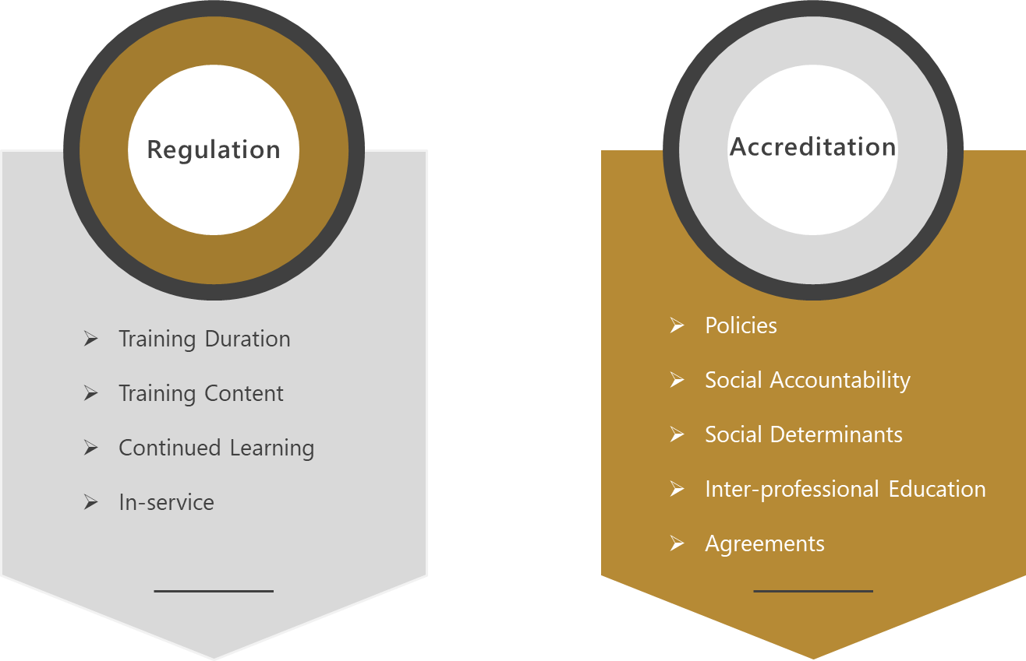
Figure 9 - Module 3 Key Areas

Indicator Data
Indicator Id | 3.01
Unique Reference Id | ID_185
Name | Existence of national and/or subnational standard on the duration and content of health workforce education and training
Possible Values | Yes/No/Partly
Definition | The following questions help determine the existence of national and/or subnational standard on the duration and content of health workforce education and training  Supporting Question Answer (2019) (2020)  Are entry requirements to health workforce education and training programmes established concerning age, previous studies, previously acquired competence by study and past professional experience? Yes Yes  Are the total number of hours to be spent on health workforce education and training established? Yes Yes  Is there a list of knowledge, skills and competencies to be acquired during health workforce education and training? Yes Yes
Value | Yes (2019) Yes (2020)
Level | UAE
Data Source | Commission for Academic Accreditation (CAA)

Indicator Id | 3.02
Unique Reference Id | ID_186
Name | Existence of national and/or subnational mechanisms for accreditation of health workforce education and training institutions and their programmes
Possible Values | Yes/No/Partly
Definition | The following questions help determine the existence of national and/or subnational mechanisms for accreditation of health workforce education and training institutions and their programmes  Supporting Question Answer (2019) (2020)  Have national and/or subnational mechanisms for accreditation of health workforce education and training institutions and their programmes been established? Yes Yes  Are national and/or subnational mechanisms for accreditation of health workforce education and training institutions and their programmes compulsory? Yes Yes  Are there national and/or subnational mechanisms for accreditation of health workforce education and training institutions and their programmes that are not compulsory? No No  If established, do national and/or subnational mechanisms for accreditation of health workforce education and training institutions and their programmes take into account national education plans for the health workforce? Yes Yes
Value | Partly (2019) Partly (2020)
Level | UAE
Comments | Registration and accreditations procedure is established for free-zones based universities however the implementation is not complete yet.
Recommendation | ‎23.2.1 Recommendation for Accreditation of non-compulsory education and training institutions
Data Source | Commission for Academic Accreditation (CAA)

Indicator Id | 3.03
Unique Reference Id | ID_187
Name | Existence of national and/or subnational standards for social accountability in accreditation mechanisms
Possible Values | Yes/No/Partly
Definition | The following questions help determine the existence of national and/or subnational standards for social accountability in accreditation mechanisms  Supporting Question Answer (2019) (2020)  Is social accountability included or reflected within national and/or subnational standards Yes Yes  Is there an involvement of civil society, other social stakeholders and communities in accreditation mechanisms? Yes Yes
Value | Yes (2019) Yes (2020)
Level | UAE
Data Source | Commission for Academic Accreditation (CAA)

Indicator Id | 3.04
Unique Reference Id | ID_188
Name | National and/or subnational standards for social accountability in accreditation mechanisms are effectively implemented
Possible Values | Yes/No/Partly
Definition | The following questions help determine the effective implementation of National and/or subnational standards for social accountability in accreditation mechanisms  Supporting Question Answer (2019) (2020)  Do national and/or subnational mechanisms for accreditation of health workforce education and training institutions and their programmes require compulsory reporting on implementation of national or subnational standards on social accountability? Yes Yes  Do the communities served by the health workforce education and training institutions participate in the decision-making of these institutions? Yes Yes  Do students learn and train in the communities that the health workforce education and training institution serves (community placements)? Yes Yes  Do health workforce education and training institutions measure their impact on the health system and populations they serve? Yes Yes
Value | Yes (2019) Yes (2020)
Level | UAE
Data Source | Commission for Academic Accreditation (CAA)

Indicator Id | 3.05
Unique Reference Id | ID_189
Name | Existence of national and/or subnational standards for the social determinants of health in accreditation mechanisms
Possible Values | Yes/No/Partly
Definition | The following questions help determine the existence of national and/or subnational standards for the social determinants of health in accreditation mechanisms  Supporting Question Answer (2019) (2020)  Are the social determinants of health included or reflected within national and/or subnational standards? Yes Yes  Do health workforce education and training institutions measure social determinants of health in the populations they serve? Yes Yes  Do health workforce education and training institutions adapt curricula according to social determinants of health in their communities? Yes Yes
Value | Yes (2019) Yes (2020)
Level | UAE
Data Source | Commission for Academic Accreditation (CAA)

Indicator Id | 3.06
Unique Reference Id | ID_190
Name | Existence of national and/or subnational standards for interprofessional education in accreditation mechanisms
Possible Values | Yes/No/Partly
Definition | The following questions help determine the existence of national and/or subnational standards for interprofessional education in accreditation mechanisms  Supporting Question Answer (2019) (2020)  Is interprofessional education included or reflected within national and/or subnational standards? Partly Partly
Value | Partly (2019) Partly (2020)
Level | UAE
Comment | Interprofessional educational aspect for accreditation standard is encouraged but not mandatory.
Recommendation | ‎23.2.2 Recommendation for implementation of accreditation standards for IPE
Data Source | Commission for Academic Accreditation (CAA)

Indicator Id | 3.07
Unique Reference Id | ID_191
Name | Existence of cooperation between health workforce education and training institutions and regulatory bodies to agree on accreditation standards
Possible Values | Yes/No/Partly
Definition | The following questions help determine the existence of cooperation between health workforce education and training institutions and regulatory bodies to agree on accreditation standards  Supporting Question Answer (2019) (2020)  Is there a coordinating mechanism or body in place for this task? Yes Yes  Are various stakeholders at national and institutional level involved in the coordination process? Yes Yes  Are there institutional mechanisms in place to coordinate accreditation systems, including negotiations with relevant ministries, government agencies and stakeholders? Yes Yes
Value | Yes (2019) Yes (2020)
Level | UAE
Data Source | Commission for Academic Accreditation (CAA)

Indicator Id | 3.08
Unique Reference Id | ID_192
Name | Existence of national systems for continuing professional development
Possible Values | Yes/No/Partly
Definition | The following questions help determine the existence of national systems for continuing professional development  Supporting Question Answer (2019) (2020)  Are there existing national and/or subnational systems for continuing professional development (CPD)? Yes Yes  If national and/or subnational systems for CPD exist, are they compulsory Yes Yes  If compulsory, are they linked to relicensure? Yes Yes  For occupations that have a national and/or subnational system for CPD, is it integrated into national education plans for the health workforce, for that occupation? No No
Value | Partly (2019) Partly (2020)
Level | UAE
Recommendation | ‎23.2.3 Recommendation for integration of CPD into National Education Plan
Data Sources | Commission for Academic Accreditation (CAA)  Ministry of Health and Prevention (MOHAP) – Training & Development Centre

Indicator Id | 3.09
Unique Reference Id | ID_193
Name | Existence of in-service training as an element of national education plans for the health workforce
Possible Values | Yes/No/Partly
Definition | The following questions help determine the existence of in-service training as an element of national education plans for the health workforce  Supporting Question Answer (2019) (2020)  Is in-service training integrated into larger national education-wide sector policies, strategies and plans? Yes Yes  Does in-service training consider and take into account national policies, strategies and plans for transforming professional, technical and vocational education and training? Yes Yes  Does in-service training consider and take into account national policies, strategies and plans for adult learning and higher education? Yes Yes
Value | Yes (2019) Yes (2020)
Level | UAE
Data Source | Commission for Academic Accreditation (CAA)

Module Summary

Education and Training - Regulation and Accreditation - Key Facts (2019,2020)
- National Standards : Available for entry criteria, hours spent and knowledge outcomes are well defined for Health Education Institutions.
- Accreditation standards : Available at national level along with mechanisms for quality control of Health Education Institutes and their programmes with below salient features
  - Defined based on multi-stakeholder and inter-sectoral agreement.
  - Holistic in nature because of inclusion of social accountability and determinants of health.
  - Attuned towards life-long learning due to CPD and Inter-professional education.
- Recommendations : Provided for below areas;
  - Accreditation of Free-zones based universities has been established but yet to be implemented.
  - IPE is encouraged however not mandatory in the accreditation system.
  - Continuing Professional Development standards are present however not in line with national education plan for health workforce.
Table 7 - Module Summary - Education and Training Regulation and Accreditation

CHAPTER 7: MODULE 4 – EDUCATION FINANCES

Overview: This module has data which quantifies public/private expenditure towards health workforce education and training across higher education, continued learning and specialist education. The benefits of data acquired in this module includes below key areas:
- Provides details on health workforce development costs
- Distribution of budget in education, skills and job creation
- Ascertains sustainable financing for continued education and International Health Regulations (IHR) core competencies
Kindly Note - We have not received data for all the indicators of this module. Details are present in section: ‎24.2.3 Module 4 – Education Finances

Key Areas
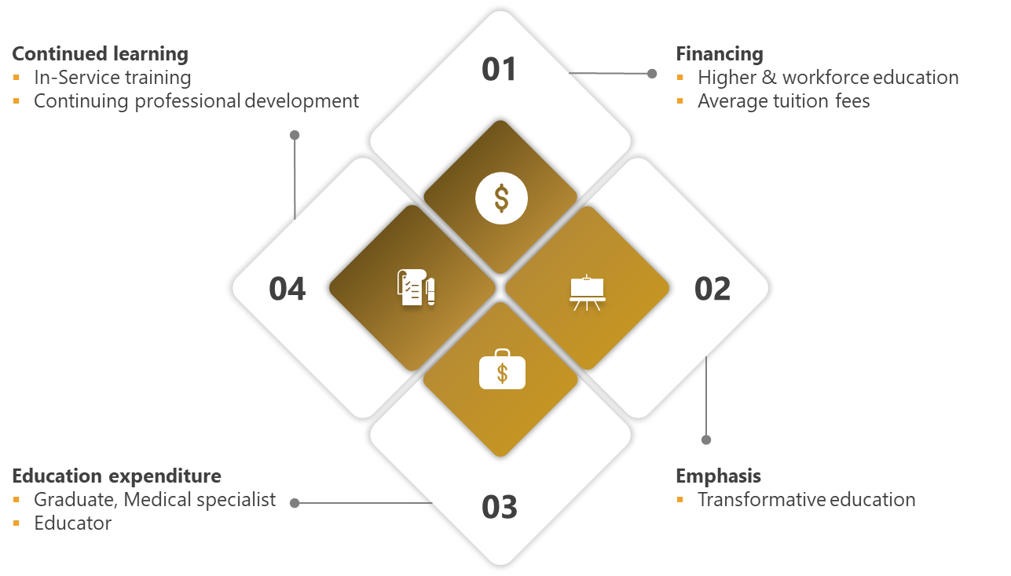
Figure 10 - Module 4 Key Areas

Indicator Data
Indicator Id | 4.01
Unique Reference Id | ID_194
Name | Total expenditure on higher education
Definition | Total expenditure on higher education, by public and private sources.
Value | 10,170,878,477.65 (2019) 8,744,672,232.00 (2020)
Unit | AED per year
Level | UAE
Data Source | Ministry of Education (MOE)

Indicator Id | 4.08
Unique Reference Id | ID_201
Name | Total expenditure on in-service training and continuing professional development
Definition | Total expenditure on in-service training and continuing professional development.
Value | 25,696,495.75 (2019) 21,541,950 (2020)
Unit | AED per year
Level | UAE (Partial – Public Sector)
Data Sources | Dubai Health Authority (DHA)  Ministry of Health & Prevention (MOHAP)  Ministry of Presidential Affairs (MOPA)

Module Summary

Education Finances - Key Facts
- Higher Education Expenditure : Heavy investment of around 10 billion (2019) and 8 billion (2020) respectively by UAE Government.
- These investments facilitate provision of quality education services and enhance a knowledge-based economy.
- Health Workforce Training Expenditures : Heavy Investments of around 26 million (2019) and 22 million (2020) made across MOHAP, MOPA and DHA entities in In-Service Training and Continuing Professional Development.
- These investments ensure that health workers have continuous skill upgradation leading ultimately to better confidence, output and career satisfaction of these workers.
Table 8 - Module Summary - Education Finances

CHAPTER 8: MODULE 5 – HEALTH LABOUR MARKET FLOWS

Overview: This module provides distribution of labour market into entries, voluntary & involuntary exits and imbalances. The defined indicators relate to the GSHRH target on the reduction of access constraints to health services, through the creation, filling and sustenance of jobs in the health and social care sectors. The benefits of data acquired in this module includes below key areas:
- Improved understanding of labour market flows
- Effective recruitment and retention policies to ensure smooth functioning of health sector workforce
- Highlights dependency on foreign workers
- Showcases movement of successful graduates into the health labour market
Kindly Note - We have not received data for all the indicators of this module. Details are present in section: ‎24.2.4 Module 5 – Health Labour Market Flows

Key Areas
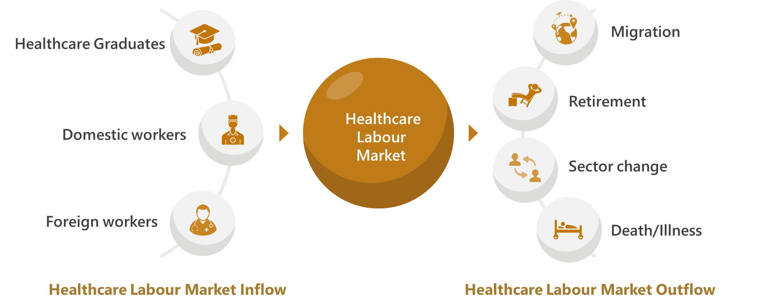
Figure 11 - Module 5 Key Areas

Indicator Data
Indicator Id | 5.06
Unique Reference Id | ID_207
Name | Unemployment rate
Definition | Unemployment rate as defined by national employment standard includes persons in unemployment are those of legal working age who are not currently employed, but who have actively sought employment and are available to take up a job opportunity.
Numerator | Number of trained health workers currently unemployed
Denominator | Total number of health workers in the labour force and unemployed health workers
Value | 4.9 (2019) Not Reported (2020)
Unit | Percent (%)
Level | UAE
Data Source | Federal Competitiveness and Statistics Centre (FCSC)

Auxiliary Information

Healthcare Private Sector Job Vacancies – Data
Source of below data is the Tawteen System of MOHRE which contains all Job Vacancies in the UAE for private sector.

- 2019 - 1516 - Total vacancies in Healthcare Private Sector in UAE.

- 2020 - 479 - Total vacancies in Healthcare Private Sector in UAE.
Category | Private Health Sector – Vacancies
 | 2019 | 2020
Medical Doctors | 655 | 250
Dentists | 37 | 1
Pharmacists | 54 | 10
Nurses | 409 | 14
Technicians | 238 | 139
Total | 1393 | 414
Table 9 - Private Sector Vacancies

Module Summary

Health Labour Market Flows - Key Facts
- Unemployment Rate : Low value of 4.9 (2019) thus indicating a satisfactory labour market situation wherein available job positions by Employers (Supply) met the skills and expectations of the workforce (Demand).
- Highest Unemployment Rate : For Dentists - 17.49% in 2019.
- Lowest Unemployment Rate : For Medical Doctors - 2.60% in 2019.
- Vacancies : Available in 2019 at 1393 and 2020 at 414.
Table 10 - Module Summary - Health Labour Market Flows

CHAPTER 9: MODULE 6 – EMPLOYMENT CHARACTERISTICS AND WORKING CONDITIONS

Overview: This module highlights regulations affecting working conditions and employment practices. It can facilitate comprehensive labour market assessment in conjunction with Module 5.
This module also focusses on self-employed and part time employee characteristics. The benefits of data acquired in this module includes below key areas:
- Progressive review of causal and descriptive labour market analyses
- Policies promoting work-life balance
- Provides inputs towards respectful working conditions
- Stresses upon health provider and facility safety based on prevention measures for health care worker and system attacks
Kindly Note - We have not received data for few indicators of this module. Details are present in section: ‎24.2.5 Module 6 – Employment Characteristics and Working Conditions

Key Areas
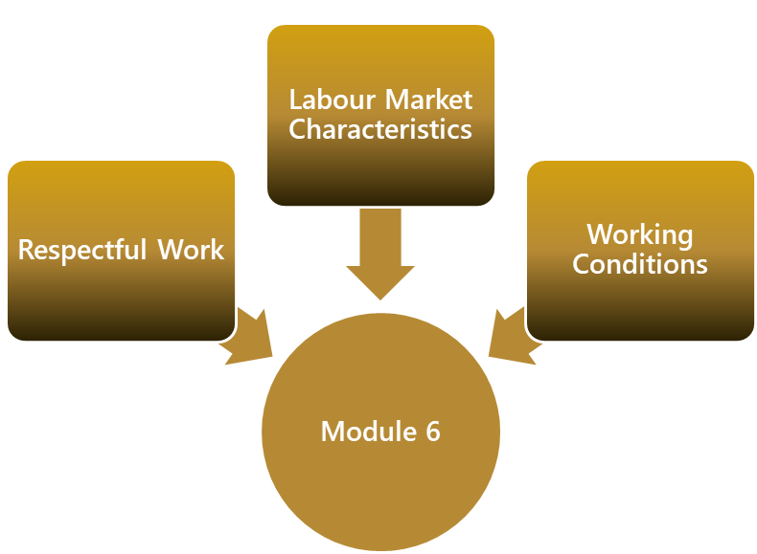
Figure 12 - Module 6 Key Areas

Indicator Data
Indicator Id | 6.01
Unique Reference Id | ID_209
Name | Number of standard working hours per week as per national law/standards
Definition | Number of standard working hours per week as per national law/standards.
Value | 48 (2019) 48 (2020)
Unit | Hours per 6 days
Comments | For Government Health Ministries, the standard work hours are  35 hours per 5 days.
Level | UAE
Data Sources | Ministry of Health and Prevention (MOHAP)  Ministry of Human Resources & Emiratisation (MOHRE)

Indicator Id | 6.03
Unique Reference Id | ID_211
Name | Existence of national/subnational policies/laws regulating working hours and conditions
Possible Values | Yes/No/Partly
Definition | The following questions help determine the existence of national/subnational policies/laws regulating working hours and conditions  Supporting Question Answer (2019) (2020)  Has the government and its competent authorities regulated the maximum number of working days allowed per week? Yes Yes  Has the government and its competent authorities regulated the premium for night work, for work on a weekly rest day, for overtime work (as a percentage of hourly pay)? Yes Yes  Has the government and its competent authorities regulated whether non-pregnant and non-nursing women can work the same night hours as men? Yes Yes  Has the government and its competent authorities regulated whether there are restrictions on night work, overtime or holiday work? Yes Yes  Has the government and its competent authorities regulated the average paid annual leave for workers with 1, 5 and 10 years of tenure? Yes Yes  Has the government and its competent authorities regulated whether regulations, laws or policies differ according to employment status? Yes Yes
Value | Yes (2019) Yes (2020)
Level | UAE
Data Sources | Dubai Health Authority (DHA)  Federal Authority for Government Human Resources (FAHR)  Ministry of Human Resources & Emiratisation (MOHRE)

Indicator Id | 6.04
Unique Reference Id | ID_212
Name | Existence of national/subnational policies/laws regulating minimum wage
Possible Values | Yes/No/Partly
Definition | This indicator is measured by the following capability question: Are health workers eligible to receive a minimal wage according to national/subnational laws?
Value | Partly (2019) Partly (2020)
Comments | Policy for Minimum Wage;  - Public Sector - Present  - Private Sector - Not Present
Level | UAE
Recommendation | ‎23.2.4 Recommendation for Regulation on Minimum Wage
Data Sources | Dubai Health Authority (DHA)  Federal Authority for Government Human Resources (FAHR)  Ministry of Human Resources & Emiratisation (MOHRE)  Abu Dhabi Health Services (SEHA)

Indicator Id | 6.05
Unique Reference Id | ID_213
Name | Existence of national/subnational policies/laws regulating social protection
Possible Values | Yes/No/Partly
Definition | The following questions help determine the existence of national/subnational policies/laws regulating social protection  Supporting Question Answer (2019) (2020)  Is there a national policy or programme regarding maternity leave or pregnancy leave? Yes Yes  Is there a national policy or programme regarding parental leave? Yes Yes  Is there a national policy or programme regarding childcare support? Partly Partly  Is there a national policy or programme regarding leave entitlements to care for sick family members? Partly Partly  Is there a national policy or programme regarding leave entitlements for in-service training and continuing professional development? Yes Yes
Value | Partly (2019) Partly (2020)
Comments | Policy for childcare support, leave for care of sick family members and leave for in-service training and CPD:  - Public Sector - Present  - Private Sector - Not Present
Level | UAE
Recommendation | ‎23.2.5 Recommendation for Regulation on Social Protection
Data Sources | Abu Dhabi Health Services (SEHA)  Dubai Health Authority (DHA)  Federal Authority for Government Human Resources (FAHR)  Ministry of Human Resources & Emiratisation (MOHRE)  Mubadala

Indicator Id | 6.06
Unique Reference Id | ID_214
Name | Health worker status in employment
Definition | Percentage of health workers who are self-employed,
Numerator | Number of health workers who are self-employed
Denominator | Total number of health workers
Value | 0.75 (2019) 0.78 (2020)
Unit | Percent (%)
Level | UAE
Data Source | Ministry of Human Resources & Emiratisation (MOHRE)

Category | Self Employed
 | 2019 | 2020
Medical Doctors | 388 | 413
Dentists | 161 | 177
Pharmacists | 190 | 196
Nurses | 67 | 61
Technicians | 126 | 136
Total | 932 | 983
Table 11 - Self Employed Workforce

Indicator Id | 6.07
Unique Reference Id | ID_215
Name | Existence of national/subnational policies/laws regulating dual practice
Possible Values | Yes/No/Partly
Definition | The following questions help determine the existence of national/subnational policies/laws regulating dual practice  Supporting Question Answer (2019) (2020)  Is there a national policy or programme regarding health workers working in a public service provision role and a role external to public services, i.e. in a completely separate private environment? Partly Partly  Is there a national policy or programme regarding health workers working in a public service provision role and a parallel role, i.e. in a private ward or clinic physically associated with a public facility but run as a separate business? Partly Partly  Is there a national policy or programme regarding health workers working in a public service provision role and another role within the public service, i.e. where private services are offered inside a public facility but outside public service operating hours or space? Partly Partly
Value | Partly (2019) Partly (2020)
Comments | - Public Sector - Partly Present  - Private Sector - Not Present
Level | UAE
Recommendation | ‎23.2.6 Recommendation for Regulation on Dual Practise
Data Sources | Abu Dhabi Health Services (SEHA)  Dubai Health Authority (DHA)  Federal Authority for Government Human Resources (FAHR)  Ministry of Human Resources & Emiratisation (MOHRE)  Mubadala

Indicator Id | 6.09
Unique Reference Id | ID_217
Name | Measures to prevent attacks on health workers
Possible Values | Yes/No/Partly
Definition | This indicator is measured by capability questions on governmental measures to prevent incidents where staff are abused, threatened or assaulted in circumstances related to their work, including commuting to and from work, involving an explicit or implicit challenge to their safety, well-being or  health.  Supporting Question Answer (2019) (2020)  Has the government and its competent authorities made the reduction/elimination of workplace violence in the health sector an essential part of national/regional/local policies and plans on occupational health and safety, human rights protection, economic sustainability, enterprise development and gender equality? Yes Yes  Has the government and its competent authorities promoted the participation of all parties concerned with such policies and plans? Yes Yes  Has the government and its competent authorities revised labour laws and other legislation and introduced special legislation where necessary, and ensured the enforcement of such legislation? Yes Yes  Has the government and its competent authorities encouraged the inclusion of provisions to reduce and eliminate workplace violence in national, sectoral and workplace/enterprise agreements? Yes Yes  Has the government and its competent authorities requested the collection of information and statistical data on the spread, causes and consequences of workplace violence? Yes Yes
Value | Yes (2019) Yes (2020)
Level | UAE
Data Sources | Abu Dhabi Health Services (SEHA)  Dubai Health Authority (DHA)  Federal Authority for Government Human Resources (FAHR)  Ministry of Human Resources & Emiratisation (MOHRE)  Mubadala

Module Summary

Employment Characteristics & Working Conditions - Key Facts
- Standard Work Hours : 48 Hours per (6 day) week is well defined and regulated.
- Regulations: Well defined and gender-neutral existing in UAE for below areas
  - Working hours in inclusive of Night shifts, Overtime and Holiday work.
[Public and Private Sectors]
  - Social protection in terms of leaves due to maternity, childcare, sick family members and training (In-Service and CPD). [Public Sector , Private Sector Partly]
  - Minimum Wage and Dual Practise. [Public Sector Only]
  - Health Workforce Safety - Protection and Elimination of Violence.
[Public and Private Sectors]
- Self-Employed : Negligible percentage of health workforce present in private sector.
- Part-Time : Well defined work permit process set by MOHRE.
- Recommendations : Provided for private sector scope inclusion for Social Protection, Minimum Wage and Dual practice aspects.

Table 12 - Module Summary - Employment Characteristics and Working Conditions

CHAPTER 10: MODULE 7 - HEALTH WORKFORCE SPENDING & REMUNERATION

Overview: This module focuses on public/private expenditure on health workforce and definition of regulation and policies towards worker compensation. In conjunction with module 4 the cumulative data provides a summary of the financial environment of health workforce. The benefits of data acquired in this module includes below key areas:
• Emphasis on monitoring Gender Pay Gap
• Economic analysis on flow of funds in health workforce
• Crucial information for budget allocation with government entities
Kindly Note - We have not received data for few indicators of this module. Details are present in section: ‎24.2.6 Module 7 – Health Workforce Expenditure

Key Areas
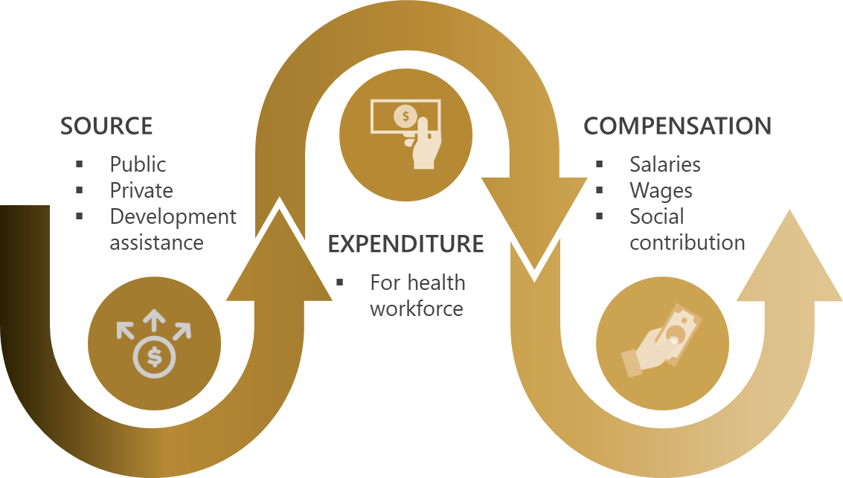
Figure 13 - Module 7 Key Areas

Indicator Data
Indicator Id | 7.06
Unique Reference Id | ID_224
Name | Existence of national/subnational policies or standards on public sector wage ceilings
Possible Values | Yes/No
Definition | Existence of national/subnational policies or standards on public sector wage ceilings. Such policies would generally be applicable not only to the health sector, but to the whole public sector.
Value | Yes (2019) Yes (2020)
Level | UAE Public Sector
Data Source | Ministry of Health and Prevention (MOHAP)

Module Summary

Health Workforce Expenditure and Remuneration – Key Facts
- Expenditure : Heavy investments made by UAE Public Health Sector (Partially) towards the National Health Workforce.
- Remuneration : Fair and Commensurate Salaries earned by health workers basis performance, experience and job requirements.
- Equal Pay : Negligible gender wage disparity is present across UAE public and private sectors.
- Wage Ceiling : Existence of public sector wage ceiling for controlling maximum salary values that can be earned by health employees however exceptions are made for special expert contracts.
Table 21 – Module Summary – Health workforce spending and remuneration

CHAPTER 11: MODULE 8 - SKILL-MIX COMPOSITION FOR MODELS OF CARE

Overview: This module contains indicators which distribute the structure of health workforce by sector facility and specialized skill set. Data obtained from this module helps ascertains human resource capacity for International Health Regulation (IHR) and Field Epidemiology programs. The benefits of data acquired in this module includes below key areas:
- Matching labour supply with health care needs of population
- Skill-mix to case-mix alignment for patient centered care
- Compliance with International Health Regulations (IHR)

Key Areas

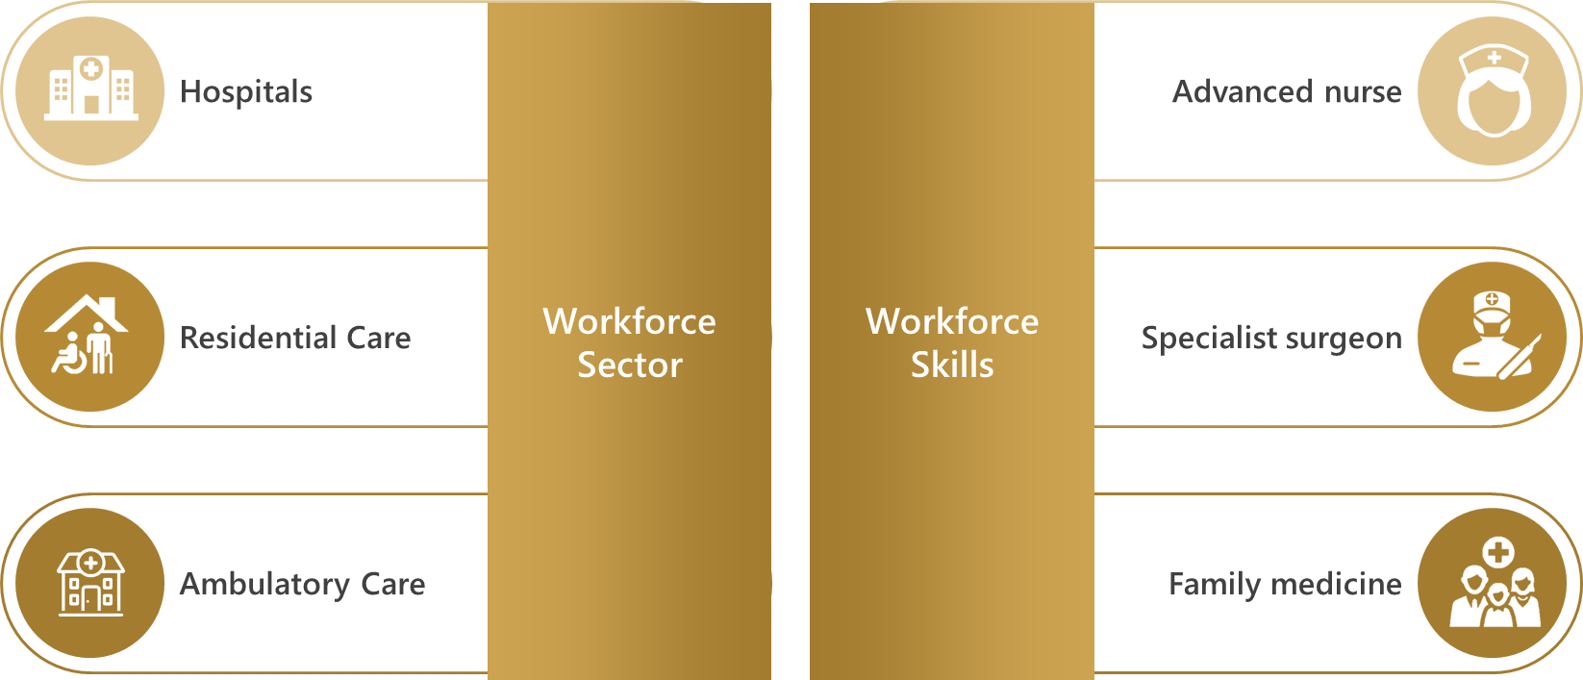
Figure 14 - Module 8 Key Area

Indicator Data
Indicator Id | 8.01
Unique Reference Id | ID_226
Name | Percentage of health workforce working in hospitals
Definition | Percentage of health workers working in hospitals among all health workers. Hospitals are defined as all types of hospitals, following the International Classification for Health Accounts 2011 (including General hospitals, Mental health hospitals, and Other specialized hospitals).
Numerator | Total number of health workers working in hospitals
Denominator | Total number of health workers
Value | 44.39 (2019) 44.82 (2020)
Unit | Percent (%)
Level | UAE
Data Sources | Department of Health (DOH)  Dubai Health Authority (DHA)  Dubai Healthcare City (DHCC)  Ministry of Health and Prevention (MOHAP)  Ministry of Presidential Affairs (MOPA)

Indicator Id | 8.02
Unique Reference Id | ID_227
Name | Percentage of health workforce working in residential long-term care facilities
Definition | Percentage of health workers, excluding social care workers, working in residential long-term care among all health workers. A residential long-term care facility is any type of nursing and residential care facility defined in the HP2.1 and HP2.9 categories of the International Classification for Health Accounts 2011.
Numerator | Total number of health workers working in residential long-term care facilities
Denominator | Total number of health workers
Value | 1.37 (2019) 1.82 (2020)
Unit | Percent (%)
Level | UAE
Data Sources | Department of Health (DOH)  Dubai Health Authority (DHA)  Dubai Healthcare City (DHCC)  Ministry of Health and Prevention (MOHAP)  Ministry of Presidential Affairs (MOPA)

Indicator Id | 8.03
Unique Reference Id | ID_228
Name | Percentage of health workforce working in ambulatory health care (primary health care level facilities)
Definition | Percentage of health workforce working in ambulatory health care presumed to be primary health care level facilities. Ambulatory care provision refers to individuals and organizations that deliver personal healthcare services on an outpatient basis. This includes diagnosis, observation, consultation, treatment, intervention, rehabilitation services, and advanced medical technology and procedures even when provided outside of hospitals.
Numerator | Total number of health workers working in ambulatory health care presumed to be primary health care level facilities
Denominator | Total number of health workers
Value | 34.20 (2019) 34.10 (2020)
Unit | Percent (%)
Level | UAE
Data Sources | Department of Health (DOH)  Dubai Health Authority (DHA)  Dubai Healthcare City (DHCC)  Ministry of Health and Prevention (MOHAP)  Ministry of Presidential Affairs (MOPA)

Indicator Id | 8.04
Unique Reference Id | ID_229
Name | Density of specialist surgical workers per 100 000 population
Definition | Density of specialist surgical workers, classified in ISCO-08 with code 2212, per 100 000 population. Specialist surgical workers are surgeons, obstetricians and anesthesiologists
Numerator | Total number of specialist surgical workers
Denominator | Total population
Value | 70.43 (2019) 68.90 (2020)
Unit | Per 100 000 population
Level | UAE
Data Sources | Department of Health (DOH)  Dubai Health Authority (DHA)  Dubai Healthcare City (DHCC)  Ministry of Health and Prevention (MOHAP)  Ministry of Presidential Affairs (MOPA)

Indicator Id | 8.06
Unique Reference Id | ID_231
Name | Existence of advanced nursing roles
Possible Values | Yes/No/Partly
Definition | The following questions help determine the existence of advanced nursing roles  Supporting Question Answer (2019) (2020)  Is there a commonly accepted definition of ‘nurse practitioner’? Yes Yes  Is there another commonly accepted definition of other types of nurses working in advanced roles? Yes Yes  Are there formal requirements to become a nurse practitioner or other type of advanced practice nurse in terms of specified training, qualifications, experience, certification/registration, etc.? Yes Yes  Are there ad-hoc/local methods for nurses being trained “on the job” to acquire specific skills that could lead to their employment in advanced roles? Yes Yes
Value | Yes (2019) Yes (2020)
Level | UAE
Data Source | Ministry of Health and Prevention (MOHAP)
Related Facts | - Specialty Nurse  Qualification : Registered Nurse and Post graduate certificate in one of nursing specialties with minimum one-year time course duration  Experience : Minimum of one-year experience post qualification in the related specialty field  - Nurse Practitioner  Qualification : Fulfill the requirements of Registered Nurse and  Completion of a Clinical Master/ Doctoral degree in nursing (Or equivalent qualification) in below areas;  - Pharmacology for prescribing drugs as a nurse practitioner  - Differential diagnosis, ordering and interpretation of diagnostic tests (Radiological and pathological tests)  - Advanced Health Assessment or;  Fulfill the requirements of Registered Nurse and National Certification or license as a Nurse Practitioner  Experience : Two (2) years’ experience post qualification as a Nurse Practitioner  - Trainings  Below trainings are available for clinical nurses to acquire specific skills that could lead to their next level employment role like Charge Nurse, Unit Manager, Nurse Manager, Nursing Supervisor, Clinical Resource Nurse etc.  - Continuous Professional Development Programme  - Continuous Education  - Preceptorship Programme  - Peer Validator Programme  - Upskilling Programme  - New Nurse Graduate Programme  - Nurse Blogs

Indicator Id | 8.07
Unique Reference Id | ID_232
Name | Availability of human resources to implement International Health Regulation core capacity requirements
Possible Values | None/ Limited/ Developed/ Demonstrated/ Sustainable Capacity
Definition | This indicator is measured (or supported) by the following (capability) items:  Capability Item Capability Value  No multidisciplinary human resource capacity available to implement IHR core capacities No capacity  Multidisciplinary human resource capacity (epidemiologists, veterinarians, clinicians and laboratory specialists or technicians) available at national level Limited capacity  Multidisciplinary human resource capacity available at national developed capacity and intermediate level Developed capacity  Multidisciplinary human resource capacity available as required at relevant levels of public health system (e.g. epidemiologist at national and intermediate level and assistant epidemiologist (or short course trained epidemiologist) at local level available) Demonstrated capacity  Capacity to send and receive multidisciplinary personnel within country (shifting resources) and internationally Sustainable capacity
Value | Sustainable capacity (2019) Sustainable capacity (2020)
Level | UAE Public Sector
Data Source | Ministry of Health and Prevention (MOHAP)

Indicator Id | 8.08
Unique Reference Id | ID_233
Name | Existence of an applied epidemiology training programme
Possible Values | None/ Limited/ Developed/ Demonstrated/ Sustainable Capacity
Definition | This indicator is measured (or supported) by the following (capability) items:  Capability Item Capability Value  No Field Epidemiology Training Programme (FETP) or applied epidemiology training programme established No capacity  No FETP or applied epidemiology training programme is established within the country, but staff participate in a programme hosted in another country through an existing agreement (at basic, intermediate and/or advanced level Limited capacity  One level (basic, intermediate, advanced) of FETP or comparable applied epidemiology training programme in place in the country or in another country through an existing agreement Developed capacity  Two levels (basic, intermediate and/or advanced) of FETP or comparable applied epidemiology training programme(s) in place in the country or in another country through an existing agreement Demonstrated capacity  Three levels (basic, intermediate, advanced) of FETP or comparable applied epidemiology training programme(s) in place in the country or in another country through an existing agreement, with sustainable national funding Sustainable capacity
Value | Limited capacity (2019) Limited capacity (2020)
Level | UAE Public Sector
Recommendation | ‎23.2.7 Recommendation for capacity of Field Epidemiology Training Programmes
Data Source | Ministry of Health and Prevention (MOHAP)

Module Summary

Skill-mix composition for models of care – Key Facts
- Facility Distribution : >40% of healthcare professionals work in Hospital settings.
- High Density of Family Medicine and Specialist Surgical workers per 100 000 population.
- IHC Capacity : Sustainable Capacity of human resources available for reporting for International Health Regulations (IHR) core capacity requirements.
- FETP Capacity : Limited Capacity of Field Epidemiology Training Programmes (FETP) conducted by Ministry of Health (UAE) with internal stakeholders only.
- Advanced Nursing : Well defined existence , recognition , entry criteria, roles & responsibilities and advanced training opportunities of Advanced Nursing roles.
- Recommendation : provided for increasing capacity of FETP trainings.
Table 13 - Module Summary - Skill-mix composition for models of care

CHAPTER 12: MODULE 9 - GOVERNANCE AND HEALTH WORKFORCE POLICIES

Overview: This module focuses on governance and policies for effective management of health workforce planning. The governance indicators reveal a country’s ability to able to coordinate an inter-sectoral health workforce agenda and possession of central HWF unit. The indicators on health workforce policies provide information on whether the country possesses health workforce planning process. The benefits of data acquired in this module includes below key areas:
- Demonstrates effective use and application of information collected from other modules
- Confirms alignment of national education plans with national health plans

Key Areas

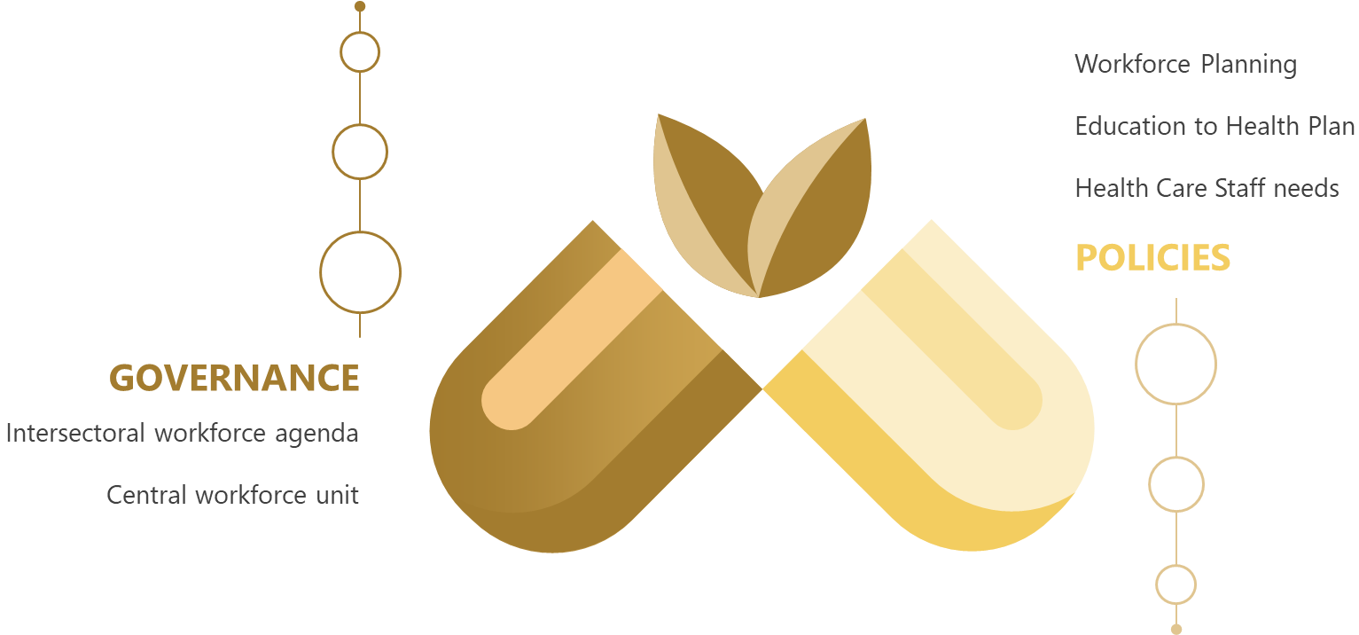
Figure 15 - Module 9 Key Areas

Indicator Data
Indicator Id | 9.01
Unique Reference Id | ID_234
Name | Existence of institutional mechanisms or bodies to coordinate an intersectoral health workforce agenda
Possible Values | Yes/No/Partly
Definition | The following questions help determine the existence of institutional mechanisms or bodies to coordinate an inter-sectoral health workforce agenda  Supporting Question Answer (2019) (2020)  Is there a coordinating mechanism or body in place for this task? Yes Yes  Are various stakeholders (ministries, public, private, nongovernmental and, international bodies) involved in the coordination process? Yes Yes  Has an agenda been formulated? Yes Yes  Has the agenda been approved at interministerial level (ministries of Education, Finance, Public Service, Health)? Yes Yes
Value | Yes (2019) Yes (2020)
Level | UAE Public Sector
Data Source | Ministry of Health and Prevention (MOHAP) – Public Policies Department

Indicator Id | 9.02
Unique Reference Id | ID_235
Name | Existence of a health workforce unit in the Ministry of Health responsible for developing and monitoring policies and plans on health workforce
Possible Values | Yes/No/Partly
Definition | The following questions help determine the existence of a health workforce unit in the Ministry of Health responsible for developing and monitoring policies and plans on health workforce  Supporting Question Answer (2019) (2020)  Are there functions to monitor health workforce policies and plans as part of the monitoring of health services development? Yes Yes  Are there institutional mechanisms in place to coordinate an intersectoral health workforce agenda, including negotiations and intersectoral relationships with relevant other line ministries, government agencies and stakeholders? Yes Yes
Value | Yes (2019) Yes (2020)
Level | UAE Public Sector
Data Source | Ministry of Health and Prevention (MOHAP) – Public Policies Department

Indicator Id | 9.03
Unique Reference Id | ID_236
Name | Existence of mechanisms and models for health workforce planning
Possible Values | Yes/No/Partly
Definition | The following questions help determine the existence of mechanisms and models for health workforce planning  Supporting Question Answer (2019) (2020)  Are clear and explicit health workforce planning objectives set up in the national health policy? Yes Yes  Is there a coordinated communication and information flow among national-level intersectoral stakeholders? Yes Yes  Is there a dedicated and established Human Resources for Health Planning Committee, a designated entity or a specific group at the national level responsible for the HWF? Yes Yes  Is there a methodology established for HWF planning? Yes Yes  Are complete data with full coverage of the population available in a sustainable manner to provide quantitative assessment required for HWF planning? Yes Yes  Are policy actions based on the recommendations of the HWF Planning Committee implemented? Yes Yes
Value | Yes (2019) Yes (2020)
Level | UAE Public Sector
Data Source | Ministry of Health and Prevention (MOHAP) – Public Policies Department

Indicator Id | 9.04
Unique Reference Id | ID_237
Name | Existence of national education plans for the health workforce, aligned with the national health plan and the national health workforce strategy/plan
Possible Values | Yes/No/Partly
Definition | The following questions help determine the existence of national education plans for the health workforce, aligned with the national health plan and the national health workforce strategy/plan  Supporting Question Answer (2019) (2020)  Do education plans for the HWF match health worker competencies with population, health systems, and health labour market needs? Yes Yes  Do plans take into account efforts to scale up transformative education and training? Yes Yes  Do recognized institutes such as national public health institutes, universities and collaborating centres offer training courses on the implementation and monitoring of Health in All Policies and related concepts? Yes Yes  Are strategic steps taken when considering and taking into account the workforce market needs and absorptive capacities for the education plan development? Yes Yes
Value | Yes (2019) Yes (2020)
Level | UAE Public Sector
Data Source | Ministry of Health and Prevention (MOHAP) – Public Policies Department

Indicator Id | 9.05
Unique Reference Id | ID_238
Name | Existence of institutional models for assessing and monitoring staffing needs for health service delivery
Possible Values | Yes/No/Partly
Definition | The following questions help determine the existence of institutional models for assessing and monitoring staffing needs for health service deliver  Supporting Question Answer (2019) (2020)  Is there a mechanism and/or responsible body in charge of determining the number of health workers of a particular occupation required to effectively and safely deliver health services in health facilities? Yes Yes  Is there a mechanism to assess the workload of health workers in health facilities? Yes Yes
Value | Yes (2019) Yes (2020)
Level | UAE Public Sector
Data Source | Ministry of Health and Prevention (MOHAP) – Public Policies Department

Module Summary

Governance and Health Workforce Policies – Key Facts
- Health Workforce Governance
  - Co-ordinated inter-sectoral health workforce agenda cutting across federal and private regulatory entities.
  - Central Health Workforce Unit in the Ministry of Health.
- Health Workforce Planning
  - Well defined objectives, inter-sectoral stakeholders and committees involved in the health workforce planning processes.
  - Alignment of National Education Plan with the National Health Workforce Plan.
  - Structure in place for monitoring quantity and workload of health workers.
Table 14 - Module Summary - Governance and health workforce policies

CHAPTER 13: MODULE 10 – HEALTH WORKFORCE INFORMATION SYSTEMS

Overview: This module defines indicators on the status of human resource for health information systems (HRHIS) systems for checking their reporting abilities against key regulations like IHR, WHO Code of Practise etc. and tracking of data pertaining to labour market areas. The benefits of data acquired in this module includes below key areas:
• Ascertains readiness of HRHIS for meeting international reporting requirements on health workforce
• Tracking of entry, stock and exit of resources from labour market
• Production of geocoded facility location data

Key Areas

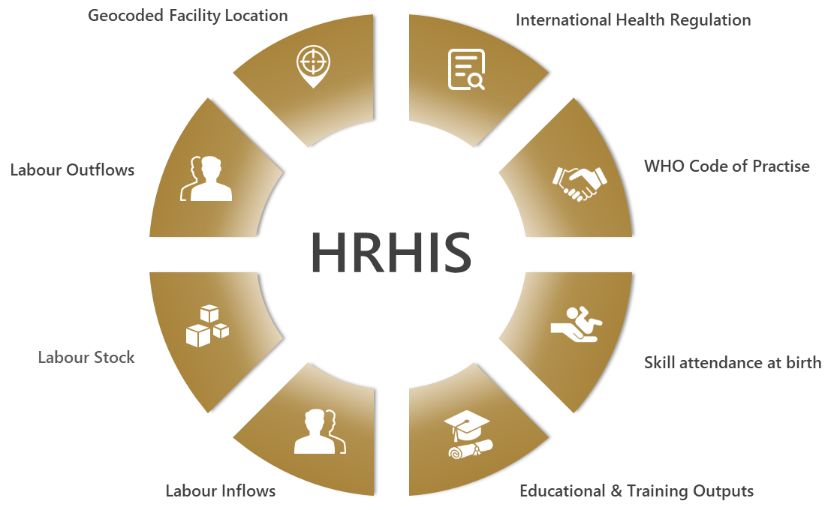
Figure 16 - Module 10 Key Areas

Indicator Data
Indicator Id | 10.01
Unique Reference Id | ID_239
Name | Ability of HRHIS to generate information to report on International Health Regulations
Possible Values | Yes/No/Partly
Definition | The following questions help determine whether HRHIS has the capacity to report on IHR and submit core indicators to the WHO Secretariat annually.
Value | No (2019) No (2020)
Level | UAE Public Sector
Recommendation | ‎23.2.8 Recommendation for reporting capabilities of HRHIS for IHR
Data Source | Ministry of Health and Prevention (MOHAP)

Indicator Id | 10.02
Unique Reference Id | ID_240
Name | Ability of HRHIS to generate information to report on implementation of the WHO Global Code of Practice on the International Recruitment of Health Personnel
Possible Values | Yes/No/Partly
Definition | This indicator will help assess whether the HRHIS has the capacity to report on the WHO Global Code of Practice on the International Recruitment of Health Personnel, and submit core indicators to the WHO Secretariat annually,
Value | Partly (2019) Partly (2020)
Level | UAE Public Sector
Recommendation | ‎23.2.9 Recommendation for reporting capabilities of HRHIS for WHO Code of Practise reporting
Data Source | Ministry of Health and Prevention (MOHAP)
Related Facts | - The Ministry of Health and Prevention (MOHAP) – UAE had submitted the WHO Global Code of Practise – National Reporting Instrument (NR) – 2021 form to WHO in September 2021.  - The form contained the filled responses for steps taken by UAE for implementing the code , Health Workforce stock data , Impact and challenges faced in migrant recruitment on account of COVID.

Indicator Id | 10.04
Unique Reference Id | ID_242
Name | Ability of HRHIS to generate information for reporting on outputs from education and training institutions
Possible Values | Yes/No/Partly
Definition | The following questions help determine whether the HRHIS has the capacity to report on outputs from education and training institutions, and submit core indicators to the WHO Secretariat annually  Supporting Question Answer (2019) (2020)  Is there a master list of accredited education and training institutions at national level? No No  If yes, is this master list geocoded? No No  Is this master list updated on a regular basis? No No  Do education and training institutions record the number of graduates by health workforce education and training, and by sex? No No  Is information on the number of graduates provided to the relevant national body on an annual basis? No No
Value | No (2019) No (2020)
Level | UAE Public Sector
Recommendation | ‎23.2.10 Recommendation for HRHIS in reporting on outputs from education and training institutions
Data Source | Ministry of Health and Prevention (MOHAP)

Indicator Id | 10.05
Unique Reference Id | ID_243
Name | Ability of HRHIS for tracking the number of entrants to the labour market
Possible Values | Yes/No/Partly
Definition | The following questions help determine whether the HRHIS has ability for tracking the number of entrants to the labour market  Supporting Question Answer (2019) (2020)  Is there a system that provides information about the health workforce? Yes Yes  If yes, does this system provide information on the inflows of the health labour market? Yes Yes
Value | Yes (2019) Yes (2020)
Level | UAE Public Sector
Data Source | Ministry of Health and Prevention (MOHAP)

Indicator Id | 10.06
Unique Reference Id | ID_244
Name | Ability of HRHIS to generate information to track active stock on the labour market
Possible Values | Yes/No/Partly
Definition | The following questions help determine whether HRHIS has ability to generate information to track active stock on the labour market  Supporting Question Answer (2019) (2020)  Is there a system that provides information about the health workforce? Yes Yes  If yes, does this system provide information on the stock of the health labour market? Yes Yes
Value | Yes (2019) Yes (2020)
Level | UAE Public Sector
Data Source | Ministry of Health and Prevention (MOHAP)

Indicator Id | 10.07
Unique Reference Id | ID_245
Name | Ability of HRHIS to generate information to track exits from the labour market
Possible Values | Yes/No/Partly
Definition | The following questions help determine whether HRHIS has the ability to generate information to track exits from the labour market  Supporting Question Answer (2019) (2020)  Is there a system that provides information about the health workforce? Yes Yes  If yes, does this system provide information on the inflows of the health labour market? Yes Yes
Value | Yes (2019) Yes (2020)
Level | UAE Public Sector
Data Source | Ministry of Health and Prevention (MOHAP)

Indicator Id | 10.08
Unique Reference Id | ID_246
Name | Ability of HRHIS to generate geocoded information on the location of health facilities
Possible Values | Yes/No/Partly
Definition | The following questions help determine whether HRHIS has the ability to generate geocoded information on the location of health facilities
Value | Partly (2019) Partly (2020)
Level | UAE Public Sector
Recommendation | ‎23.2.11 Recommendation for HRHIS production of geocoded health facility locations
Data Source | Ministry of Health and Prevention (MOHAP)

Module Summary

Health workforce Information Systems – Key Facts
- IHR Reporting : Manual email-based process for IHR reporting to WHO.
- WHO Global Code of Practise Reporting : Only Health Worker Stock data from Bayanati (HRHIS) is used for Code of Practise reporting on migrant worker recruitment.
- Outputs from Education Institutions Reporting : Bayanati (HRHIS) system does not track data pertaining to outputs from Health Education & Training institutes.
- Health Worker Tracking : Bayanati (HRHIS) has data for tracking Health Worker Entries, Stock and Exits from Federal Health Labor Market.
- Geocoded Location Tracking : Bayanati (HRHIS) does not track Geocoded facility locations.
- Recommendations : Provided for automation of IHR reporting , Tracking of Education Outputs, Geocoded Location of Facilities and Worker Training data.
Table 15 - Module Summary - Health workforce information systems

CHAPTER 14: NHWA INTERNATIONAL COMPARISONS

Overview
Key NHWA health workforce indicators are presented here pertaining to Gender Distribution and Category-wise health worker density per 10 000 population.
UAE’s performance in these Indicators against selected chief countries are presented below to ascertain global health workforce comparability.
Note: All the indicator data present in this chapter are obtained from (WHOs - Global Health Workforce Statistics) and latest year values as available have been utilized.

Gender Distribution Indicator
We are measuring gender distribution based on difference between percentage of male workforce and percentage of female workforce.

Medical Doctor
As per below mentioned countries, the gap in Medical Doctors workforce between men and women is highest in UAE with 14.10%. In UK there is lowest gender distribution parity in Medical Doctor workforce with gap of 2.44%.

Figure 17 - Medical Doctor - Global Gender Comparison

Nursing
As per below mentioned countries, the gap in Nursing workforce between men and women is highest in Japan with -84.99%. In UAE the gap between men and women in the Nursing workforce is -58.72%.

Figure 18 - Nurses - Global Gender Comparison

Category-wise Health Worker Density indicator

Medical Doctor per 10 000 population
As per below mentioned countries, highest Medical Doctor density per 10 000 population is in Italy with 80.13. In the UAE this figure is at 27.

Figure 19 - Global Medical Doctor densities

Nurses and Midwifery per 10 000 population
As per below mentioned countries, highest Nurse and Midwife density per 10 000 population is in Norway with 183.50. In the UAE this figure is at 98.22.

Figure 20 - Global Nurse and Midwife Density

Dentists per 10 000 population
As per below mentioned countries, highest Dentists density per 10 000 population is in Belgium with 10.77. In the UAE this figure is at 8.41.
Figure 21 - Global Dentists Density

Pharmacists per 10 000 population
As per below mentioned countries, highest Pharmacist density per 10 000 population is in Belgium with 19.44. In the UAE this figure is at 13.71.

Figure 22 - Global Pharmacist Density

CHAPTER 15: MOHAP RECOMMENDATIONS

Overview
The NHWA modules have certain indicators which are qualitative in nature and are used to assess the capabilities of a country’s health workforce policies and regulations in improving the state of the health workforce. In the above-mentioned chapters pertaining to individual NHWA Modules, certain indicators are in the form of questions which have possible responses as Yes, No or Partly.
For those indicators wherein identified stakeholders have provided responses as No or Partly, We at MOHAP have analyzed those responses and are providing recommendations towards those questions whereby 100% indicator compliance can be achieved in UAE.

Capability Indicator Status
# | Module | Total |  | Yes |  | No |  | Partly
2 | Education & training |  | 1 |  | 1 |  | 0 |  | 0
3 | Education & training regulation and accreditation |  | 9 |  | 6 |  | 0 |  | 3
4 | Education finances |  | 1 |  | 0 |  | 0 |  | 0
6 | Employment characteristics and working conditions |  | 6 |  | 2 |  | 0 |  | 3
7 | Health workforce spending and remunerations |  | 1 |  | 1 |  | 0 |  | 0
8 | Skill-mix composition for models of care |  | 3 |  | 3 |  | 0 |  | 0
9 | Governance and health workforce policies |  | 5 |  | 5 |  | 0 |  | 0
10 | Health workforce information systems |  | 7 |  | 3 |  | 2 |  | 2
Table 16 - Capability Indicator Status

MOHAP Recommendations

Recommendation for Accreditation of non-compulsory education and training institutions
Indicator | Accreditation mechanisms for education and training institutions and their programmes
Question | Are there national and/or subnational mechanisms for accreditation of health workforce education and training institutions and their programmes that are not compulsory?
Owner | Ministry of Education
Overview | - This indicator ascertains non-compulsory areas for accreditation of health workforce education and training institutions and their programmes.  - Education areas such as governance, student faculty, facilities , research , legal compliance etc. need to be accredited periodically to ensure standardized , high quality and relevant education is being imparted.  - Commission for Academic Accreditation (CAA) emphasizes the existence of an Industrial Advisory Board for each health education programme wherein MOHAP and other health authorities plan to design curriculum for health care workers and build new competency frameworks for Medicine, Pharma, Nursing and Dentistry.  - As per NHWA report of 2018, the accreditation standards were exempted for education and training institutes that fell under the free zones in UAE.  - However, for years 2019 and 2020, the accreditation procedures were established for free-zones however their implementation was not completed.
Recommendation : The established accreditation standards for Free-Zones based higher education institutions in the UAE should be implemented and mandatorily applied.

Recommendation for implementation of accreditation standards for IPE
Indicator | Standards for interprofessional education (IPE)
Question | Is interprofessional education included or reflected within national and/or subnational standards?
Owner | Ministry of Education
Overview | - This indicator deals with inclusion of standards for IPE in educational accreditation.  - IPE education is a collaborative approach to learning resulting in improved knowledge and health outcomes.  - IPE is regarded as an integral mitigation strategy towards global health workforce crisis which takes place in many different countries and healthcare settings across a range of income categories.  - As per NHWA report of 2018 and even for year 2019, IPE training in UAE was encouraged but not mandatory.  - However, 2020 onwards, despite still not being mandatory, it was heavily encouraged and promoted at graduate level as well as during the in-service training.
Recommendation : IPE implementation should be made mandatory in Accreditation process. Series of steps detailed below should be undertaken by licensed health education universities in order for successful accreditation of their IPE implementation.

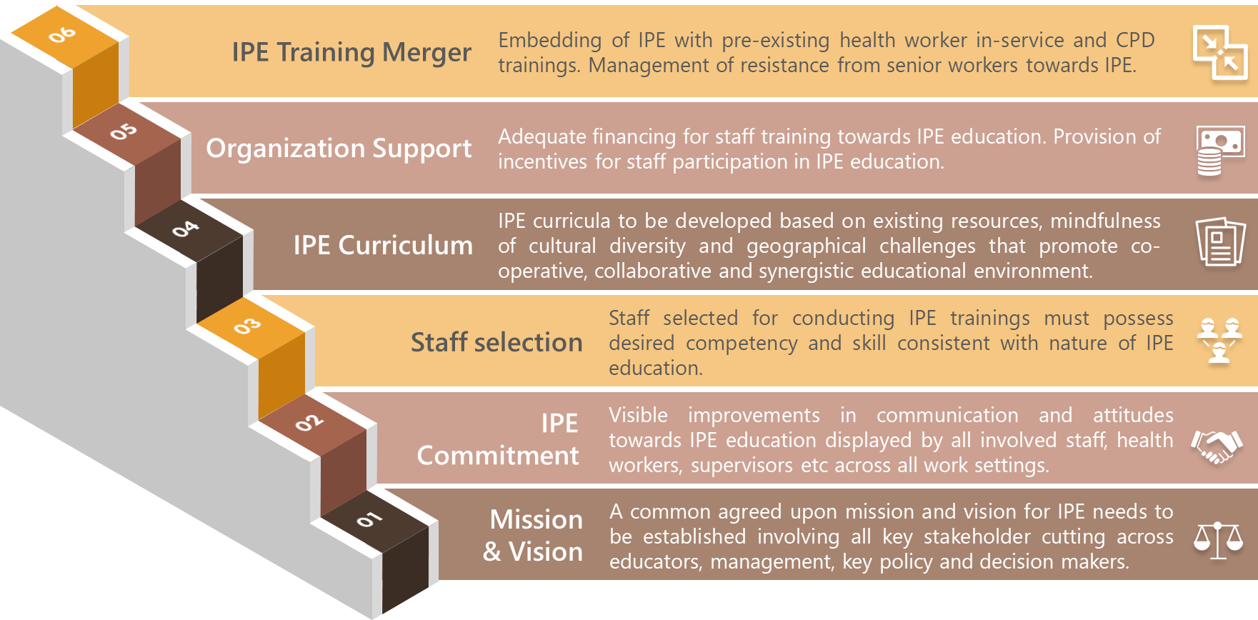
Figure 23 - Steps for accreditation of IPE

Recommendation for integration of CPD into National Education Plan
Indicator | Continuing Professional Development
Question | For occupations that have a national and/or subnational system for CPD, is it integrated into national education plans for the health workforce, for that occupation?
Owner | Ministry of Health and Prevention
Overview | - This indicator verifies the incorporation of CPD into the national education plan for health workforce.  - CPD is used to describe learning activities that professionals partake in to develop and enhance their skills.  - As per NHWA report of 2018 and till 2020, the CPD standards for health workforce education are not integrated with national education plan.
Recommendation : A standard structure for CPD needs to be established in order to ensure complete training and development of every individual healthcare worker along with certification for essential re-licensure. Integral aspects of CPD should be included in the Ministry of Education’s National Strategy of Higher Education 2030.

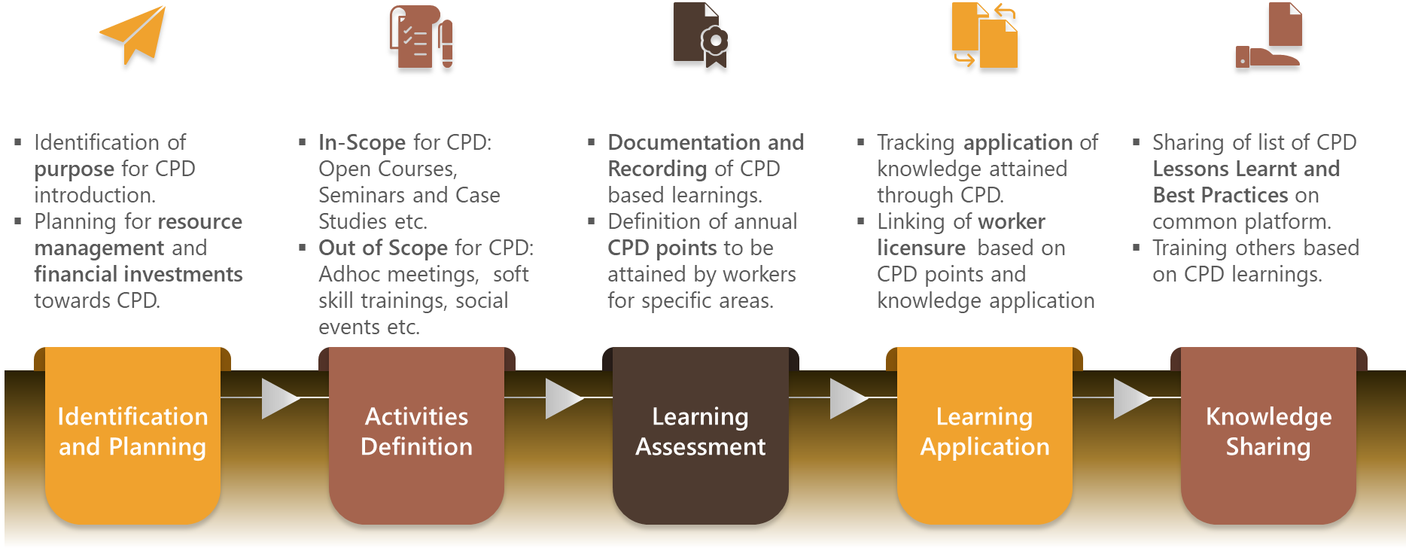
Figure 24 - CPD Inclusion process in National Education Plan

Recommendation for Regulation on Minimum Wage
Indicator | Regulation on minimum wage
Question | Are health workers eligible to receive a minimal wage according to  national/subnational laws?
Owner | Ministry of Human Resources & Emiratisation
Overview | - This indicator checks the existence of national/regional policies regulating minimum wage.  - Minimum wage is the minimum amount of remuneration that an employer is mandated to pay their employees for a given time period and for particular work performed.  - This regulation ensures worker protection against excessively low and incommensurate wages.  - Regulation for Minimum Wage is present in the UAE public sector.  - However, for years 2019 and 2020 , there was no provision for Minimum Wage in the UAE private sector despite worker salaries being highly competitive and negotiable in addition to being simultaneously considerate of employees’ basic needs.  - Title 3 - Article 63 of the Labor law mentions that the minimum wage and cost of living index is determined either in general or for a particular area or a particular profession by virtue of a decree and consent of the Cabinet.
Recommendation : Not needed since UAE labour law has introduced Minimum Wage for employees in the private sector, effective from February 2, 2022.

Recommendation for Regulation on Social Protection
Indicator | Regulation on social protection
Question | Is there a national policy or programme regarding leave entitlements to care for sick family members?
Owner | Ministry of Human Resources & Emiratisation
Overview | - This indicator checks the existence for national policy regarding leave entitlements for taking care of sick family members.  - In the UAE Public Sector , regulations exist for all aspects of Social Protection.  - However, for years 2019 and 2020 , in the UAE Private sector, there was no explicit provision for compassionate leaves for looking after sick family members or bereavement.  - In such misfortunes, employees would request for leaves to be deducted from their annual leave, or consider unpaid leave or any other arrangement, which the employer would agree to.
Recommendations : UAE labour law has introduced Compassionate Leave ranging 3 to 5 days for bereavement, effective from February 2, 2022.
Additionally, Fair amount of annual leaves must be granted to both genders towards looking after sick family members inclusive of below aspects;
- Family Member Definition : The list of family members for whom an employee may request sick leave for family care or bereavement purposes should be well defined.
- Terms : The total number of permissible days for such leave should be clearly stated. Employers should not be liable to pay employees for such leaves.
- Evidences : These sorts of leaves should be granted basis successful production of valid evidences that confirm the veracity of the reason for leave.
- Scope : Which kind of leaves that can considered under Compassionate Leaves should be clearly defined, E.g. - Bereavement Leaves and Leave for taking care of sick family members.

Recommendation for Regulation on Dual Practise
Indicator | Regulation on Dual Practise
Question | Is there a national policy or programme regarding;  1. health workers working in a public service provision role and a role external to public services, i.e. in a completely separate private environment?  2. health workers working in a public service provision role and a parallel role, i.e. in a private ward or clinic physically associated with a public facility but run as a separate business?  3. health workers working in a public service provision role and another role within the public service, i.e. where private services are offered inside a public facility but outside public service operating hours or space?
Owner | Ministry of Human Resources & Emiratisation
Overview | - This indicator checks the existence for national policies/laws regulating dual practice.  - Dual Practise entails health workers functioning in dual health service delivery sectors such as public on public, public on private and/or private on private.  - One of the main advantages of Dual Practise is supplementary income for health workers and drawback is that of potential compromise in quality of service. Thus, it needs to be regulated properly.  - For years 2019 and 2020 , In UAE , Dual Practise was majorly regulated in public sector however not regulated in private sector.
Recommendation : In the UAE private sector, Laws need to be devised which facilitate flexible and ethical functioning of workers in private on private or private on public (Dual Practise) settings.

Recommendation for capacity of Field Epidemiology Training Programmes
Indicator | Applied epidemiology training programme
Question | Is there an existence of an applied epidemiology training programme?
Owner | Ministry of Health & Prevention
Overview | - This indicator checks the existence of Field Epidemiology Training Programmes (FETP) typically conducted by a country’s Ministry of Health.  - FETP comprise of lectures, workshops, technical discussions and field visits that strengthen public health workers’ competency for detection and response towards international or local disease outbreaks.  - As per NHWA report of 2018, A limited capacity for FETP existed in the UAE on account of an annual in-house epidemiology workshop conducted on 13th Dec 2018 which comprised of few MOHAP employees at the Training & Development Center (TDC).  - For 2019 and 2020 as well there was limited capacity for FETP on account brief workshops conducted by MOHAP with internal stakeholder participation only.
Recommendation : For a sustainable capacity, comprehensive Field Epidemiology Training Programmes utilizing baselined training materials should be undertaken each year with multiple levels (basic, intermediate and advanced) of training attended by multiple stakeholders across federal and private health regulation entities.
A comprehensive field epidemiology programme should exist comprising of below key areas;
- Developed training material : Surveillance disease systems and laboratory techniques based on actual epidemics should be included. Usage of Epidemiological cases studies revealing correct methods for outbreak data analysis and reporting. Inclusion of material having methods to deal with complex emergency situations.
- Organized training courses : Conducting of epidemiological workshops and field visits utilizing the baselined training material. Defined objectives for increasing participant readiness for complex emergency situations. Local staff employment for communicable disease surveillance.
- Multi-stakeholder participation : Multi-disciplinary stakeholders should participate in trainings based on existing programmes in other countries. Participants should be incentivized to work as field epidemiologists forming a cohort at country level. Participants should in turn be trained to conduct similar workshops on epidemiology.

Recommendation for reporting capabilities of HRHIS for IHR
Indicator | HRHIS for reporting on International Health Regulations
Question | Does the Human Resource for Health Information System (HRHIS) have ability to generate information to report on International Health Regulations?
Owner | Ministry of Health & Prevention
Overview | - This indicator checks the reporting abilities of HRHIS system for International Health Regulations (IHR).  - IHR are legal regulations adopted by WHO for aiding countries in saving their population by reporting instances of local or foreign diseases to WHO through a designated IHR National Focal Point (NFP).  - In the UAE, all sectors report on public health events of global and national relevance through a regular reporting mechanism namely Daily Epidemic Reports within the UAE, which is overseen by MOHAP (IHR NFP).  - As per NHWA report of 2018, the system for IHR reporting involved manually entered form-based reports that are emailed to WHO. This is applicable for 2019 and 2020 as well.
Recommendation : This current email reporting system needs to be upgraded to an integrated electronic platform (HRHIS) system encompassing national and local levels, as well as human and animal health sectors.

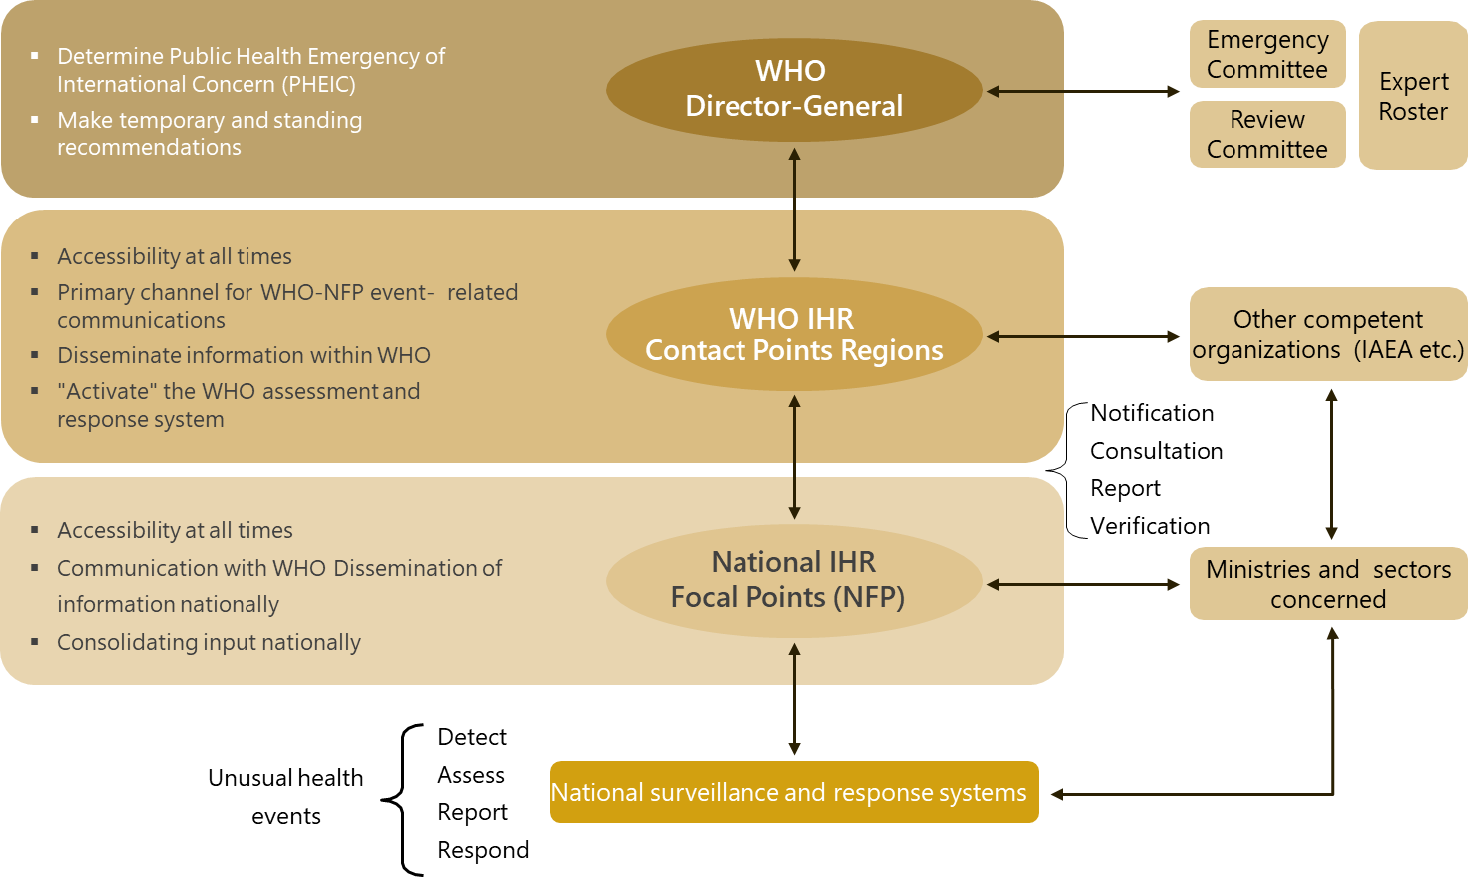
Figure 25 - IHR Framework

Recommendation for reporting capabilities of HRHIS for WHO Code of Practise reporting
Indicator | HRHIS for WHO Code of Practice reporting
Question | Does the Human Resource for Health Information System (HRHIS) have ability to generate information to report on implementation of the WHO Global Code of Practice on the International Recruitment of Health Personnel?
Owner | Ministry of Health & Prevention
Overview | - This indicator checks the ability of HRHIS systems towards reporting of WHO Global Code of Practise.  - The WHO Global Code of Practise provides a platform on which countries report their policy and statistical data related to the International Recruitment of their migrant workforce.  - MOHAP (UAE) had submitted data on WHOs’ National Reporting Instrument (2018) link in the year 2019.  - The Policy data for which was manually collected from multiple stakeholders across MOHAP and MOHRE.  - The Statistical workforce data was manually collected from all healthcare regulator entities across MOHAP, DOH and DHA.  - In 2019, From the HRHIS (Bayanati) and other licensing systems, only Worker Stock data was being submitted and not Country of Training data.
Recommendation : Country of Training data needs to be captured in the Bayanati (HRHIS) system and accordingly leveraged for WHO Global Code of Practise reporting.

Recommendation for HRHIS in reporting on outputs from education and training institutions
Indicator | HRHIS for reporting on outputs from education and training institutions
Question | Does the Human Resource for Health Information System (HRHIS) have ability to generate information for reporting on outputs from education and training institutions?
Owner | Ministry of Health & Prevention
Overview | - This indicator checks the reporting abilities of HRHIS system towards the outputs from education and training institutions.  - These outputs typically constitute below mentioned areas of accredited education and training institutions:  - Annual updated list of accredited education & training institutions and their programmes  - Applications/Admissions/Enrollments made towards these programmes  - Faculty to Student ratios  - Successful graduates’ data  - Dropouts data  - Benefits for containing outputs for education and training institutions in the HRHIS system:  - Aids planning towards health workforce projection and capacity  - Supports budgetary considerations for new job creation  - Promotes judicious international health workforce recruitment  - Optimizes training needs for health workforce  - Facilitates collaboration between health and education ministries  - Derives core indicators which can be submitted to WHO Secretariat annually  - As per NHWA report of 2018, the Bayanati HRHIS System only contained the educational qualification details of the employees and not the education outputs. This is applicable for 2019 and 2020 as well.  - The MOHAP - Licensing system as well does not contain the educational output details of the employees
Recommendation : MOHAP – Licensing system should have access to such data upon completion of Enterprise Data Warehouse (EDW) solution which will have Ministry of Education systems and Licensing System as source data systems.

Recommendation for HRHIS production of geocoded health facility locations
Indicator | HRHIS for producing the geocoded location of health facilities
Question | Does the Human Resource for Health Information System (HRHIS) have ability to generate geocoded information on the location of health facilities?
Owner | Ministry of Health & Prevention
Overview | - This indicator checks the existence of geocoded location of health facilities in the HRHIS system.  - Geocoded location corresponds to the latitudinal and longitudinal location tracked down to nearest constituent town, ward or neighborhood of that particular health facility on the earth’s surface.  - Methods of geocoding typically include below areas:  - Using GPS devise for facility location.  - Satellite imagery and aerial photography platforms like Google Map, Google Earth etc.  - Using scanned and georeferenced hand-drawn maps.  - Location determination through existing maps.  - For 2019, The geocoded health facilities location data is not captured in Bayanati System.  - Currently MOHAP-Licensing system has geocoded facility url links for some of the health worker staff.
Recommendation : MOHAP – Licensing system should be upgraded to store the geocoded locations of all the facilities associated with each staff.

CHAPTER 16: CHALLENGES

General Challenges
The National Health Workforce Account (NHWA) was formulated as a means to meet the below mentioned global health workforce challenges faced by countries:
- Shortage of national health workforce
- Provision of high-quality education and training that supports the needs of health systems
- Equitable deployment of health workers to match populations’ needs
- Performance monitoring to ensure high-quality care nationwide
- Health workforce promotion and job retention

The NHWA programme can aid countries to address or reconsider major policy questions related to current HWF challenges and optimizing planning systems such as:
- Is the current health workforce stock sufficient, skilled and accessible for providing quality services thereby resulting in satisfaction of population needs?
- Are the identified gaps in health workforce situation addressable through optimal resource allocation, formulation of effective policies, bolstering of public and private sector partnerships and making sound investments in education and workforce production?
- What is the financial feasibility in terms of fiscal investment (salaries) and inter-sectoral negotiations for implementing policies that improve health workforce performance?
- Can the health workers entry into the labour market counterbalance the exits?
- Can financial incentives attract health workers in underserved areas and aid in job retention and balanced geographical distribution?

Challenges in NHWA Data Collection
The biggest challenge in the accurate data collection for all NHWA Modules in the UAE was that data is scattered across 7 emirates, multiple regulatory ministries and the private sector. For each NHWA module, identification of the correct stakeholder for the respective data was the key step that was taken during a NHWA Orientation workshop which included designated individuals from each Ministry in the UAE. Despite this initiative, several indicator data was not successfully obtained due to unavailability with the respective stakeholder.
The specific module-wise data collection challenges are present below;

Module 1 – Active Health Workforce Stock
Indicator | Share of foreign-trained health workers
Overview | - This indicator focusses on health workers who have obtained qualification degree outside of the UAE and practice within UAE.  - We contacted the official multiple healthcare regulatory entities for acquiring Manpower data with different disaggregation’s like gender, age groups, sector, training etc.  - For Training data, we essentially sought fields such as Degree Name, Institute Name, Graduation Date, Country of Training etc.
Challenge | Majority of the contacted stakeholders responded with partial or complete unavailability of such kind of Training data of their health workers.
Action | We shall request the concerned entities to mandatorily start tracking the above-mentioned data for existing employees and make this data a licensing requirement for new employee onboarding process.

Module 2 – Education & Training
Indicators | Applications for education and training  Ratio of admissions to available places  Exits/drop-out rate from education and training programmes  Graduation rate from education and training programmes
Overview | The above-mentioned indicators are pertaining to inputs (Applications, Admissions) and outputs (graduates, dropouts from Higher Health Education Institutions.
Challenge | - We have received the numerator values for above indicators from Ministry of Education (MOE) however still need the denominator values for these indicators.  - For E.g.: Data for number of Applications and Admissions for higher health education programmes is present however; Data for the number of available places for those programmes is not.
Action | - MOE collect education and training based statistical and financial data from their individual licensed universities using the Centre for Higher Education Data and Statistics (CHEDS) data collection process.  - We have provided a comprehensive pending data items file (present below) in relation to above indicators to the Ministry of Education.  - They will need to share below file with each of the individual higher health education institutions for filling after obtaining necessary approvals from their Undersecretary.

Module 4 – Education Finances
Indicators | Total expenditure on health workforce education  Average tuition fee per student  Investment in transformative education and training  Expenditure per graduate on health workforce education  Cost per graduate of medical specialist education programmes  Cost of qualified educators per graduate
Overview | These indicators focus around expenditures and investments incurred towards health workforce education.
Challenge | - MOE has shared with us Total Expenditure on Higher Education across all specializations however expense data specific to Higher Health Education, Graduates, Tuition Fee and Educators has not been shared due to unavailability.
Action | - Accordingly, we have provided a comprehensive pending data items form file (present below) in relation to above indicators to the MOE.  - We recommend MOE to use these forms as reference for any future data collection from their licensed individual higher health education institutions after obtaining necessary approvals from their Undersecretary.

Module 5 – Health Labour Market Flows
Indicators | Graduates starting practice within one year  Replenishment rate from domestic efforts  Entry rate of foreign health workers
Overview | - Data in this module mainly relates to newly active workers - Local, Expat or Fresh Graduates, who have just entered the UAE health labour market for the first time in a given year.  - Prior Work History and Graduation History of the workers is needed to fulfil these criteria.
Challenge | - Majority of contacted stakeholders have not entirely captured the Prior Work History inclusive of Prior Company Name, Prior Company – Country, Prior Company Service Duration etc.  - Similar situation for Graduation/Training data.
Action | We shall request the concerned entities to mandatorily start tracking the above-mentioned data for existing employees and make this data a licensing requirement for new employee onboarding process.

Indicator | Voluntary exit rate from health labour market  Involuntary exit rate from health labour market
Overview | - Data in this module mainly relates to previously existing active workers who had left the UAE Health Labour Market in a given year for below possible reasons;  - Voluntary - Emigration, temporary leave, change of sector, early retirement etc.  - Involuntary - death, retirement (excluding early retirement), suspension from work, long-term illness etc.  - Resignation details such as length of service and resignation reason help fulfil above criteria.  - In addition to resignation details of health workers, their Emirates ID (United Arab Emirates Resident Identity Card) can help track actual exist from UAE health labour market by verification across multiple job resignations within the country.
Challenge | - Entities are typically tracking Health Worker licenses which have been cancelled or blocked or de-activated or suspended etc. and not the resignations.  - Emirates-ID is typically not captured for health workers licensed for the first time in the UAE and on account of data sensitivity is shared with utmost caution.
Action | We shall request the concerned entities to mandatorily start tracking the health worker resignation details in addition to their licensing status and also capture the Emirates-ID even during first time licensure.

Indicator | Vacancy rate
Overview | - Data in this module mainly relates to Ratio of unfilled healthcare job posts to total number of posts  - We have received data from MOHRE for healthcare job vacancies in Private Sector from the Tawteen system.
Challenge | - MOHRE has a Tasheel system which contains all job work permits however is not integrated with the Tawteen system. Due to which Filling of vacancies data is not captured.  - Majority of the public sector healthcare entities do not have the healthcare job vacancies data.
Action | We shall request the concerned Public and Private healthcare entities to mandatorily start tracking the job vacancies and end of year filling status of the same.

Module 6 – Employment Characteristics and Working Conditions
Indicator | Health workers with a part-time contract
Overview | This indicator is applicable for those health workers who work below national standard working hours and across multiple sectors as well.
Challenge | - Majority of contacted stakeholders do not have this data readily available.
Action | - In the UAE, there are rare occasions where professionals opt for working across multiple sectors and need permit from MOHRE for undertaking part-time work.  - We shall request the concerned Public and Private healthcare entities mandatorily track Part-Time health workers working across multiple facilities internal or external to those entities.

Module 7 – Health Workforce Expenditure
Indicators | Total expenditure on health workforce  Total expenditure on compensation of health workers  Entry-level wages and salaries
Overview | - These indicators correspond to the total expenditure inclusive of compensations, salaries, social contributions and training incurred on health workforce.  - We have received health worker expenditure and salaries data from all entities except DOH and DHCC.
Challenge | DOH and DHCC need to individually collect these salaries and expenditure information from each of their constituent health facilities.
Action | We shall recommend to these entities the usage of integrated systems to capture workforce salaries and overall expenditure across their facilities.

Glossary
Source: WHO - (National Health Workforce Account - A Handbook)
Term | Definition
Accreditation | A process by which an officially approved body, on the basis of assessment of learning outcomes and/ or competences according to different purposes and methods, awards qualifications (certificates, diplomas or titles), or grants equivalences, credit units or exemptions, or issues documents such as portfolios of competences. The term accreditation applies to the evaluation of the quality of an institution or a programme as a whole.  - Accreditation mechanisms: Mechanisms and procedures for implementation of an accreditation process.  - Accreditation standards: Standards that guide health workforce education programme development and evaluation, facilitate diagnosis of strengths and weaknesses relating to the education programme, and stimulate quality improvement.  - Accreditation systems: A system that is: based on standards; supported by a legislative or legal instrument; independent; transparent; non-profit-making; accountable; representative of, but independent from all major stakeholders; and efficiently administered.
Active health worker | One who provides services to patients and communities (practising health worker) or whose medical education is a prerequisite for the execution of the job (e.g. education, research, public administration) even if the health worker is not directly providing services (professionally active health worker). If data are not available for practising or professionally active health workers, data with the closest definition can be used, such as “health worker licensed to practice”.
Active health workforce stock | This comprises of the size, composition and distribution of health workforce within a country.
Admissions | The number of applications which successfully met the entry criteria of education programmes and are thus offered Admissions for the 1st year of those education programmes.
Advanced practice nurse | A registered or other professional nurse who has acquired the expert knowledge base, complex decision-making skills and clinical competencies for expanded practice, the characteristics of which are shaped by the context and/or country in which the nurse has credentials to practise. A master’s degree is recommended for entry level.
Ambulatory care | Institution with Provision of health care services directly to outpatients in daycare or home care settings.
Ancillary Services | Institution with Provision of patient transportation and labs (medical, diagnostic, dental) etc. services.
Applications | The number of applications which successfully met the entry criteria of those programmes and are thus offered Admissions for the 1st year of education programmes.
Compensation of employees | The total remuneration, in cash or in kind, paid by an enterprise to an employee in return for work performed by the latter during the accounting period. It includes wages, salaries, and all forms of social benefits, payments for overtime or night work, bonuses, allowances, as well as the value of in-kind payments such as the provision of uniforms for medical staff.
Continuing professional development | Training that is beyond clinical update and includes wide-ranging competences like research and scientific writing; multidisciplinary context of patient care; professionalism and ethical practice; communication, leadership, management and behavioral skills; team building; information technology; auditing; and appropriate attitudinal change to ensure improved patient service, research outcomes, and attainment of the highest degree of satisfaction by stakeholders. The form of continuing professional development (CPD) may include: courses and lectures; training days; peer review; clinical audit; reading journals; attending conferences; e-learning activity. CPD may be included in national standards of conduct, performance and ethics that govern health workers.  Continuing professional development (mandatory)  National systems for continuing CPD may be voluntary or mandatory. Mandatory systems may include the requirement for both verifiable and general and non-verifiable CPD. Verifiable CPD is activity that meets an agreed definition of CPD and for which there is documentary evidence that the health worker has undertaken CPD with concise educational aims and objectives; clear anticipated outcomes; and quality controls.
Domestic trained health worker | A health worker who obtained his/her first qualification in the country where s/he is entitled to practice.
Entrants | New students to the institutions who joined in the starting of the academic year.
Enrolments | The number of students who are actually attending the classes of the education programmes.
Family medicine practitioner | Part of generalist medical practitioners classified in ISCO-08 code 2212. Also referred to as general practitioners and in some countries considered as a specialization, they provide person-centred continuous and comprehensive medical care to individuals and families in their communities. This group does not include resident medical officers, medical interns or other generalist medical practitioners not in general practice activities.
Field epidemiology training programme (FETP) | A health training programme with field investigations to develop experience and specialist skills based on practical application of epidemiological methods. FETP training levels are defined as:  - Basic level: for local health staff, comprising limited classroom hours interspersed throughout 3–5 months on-the-job field assignments to build capacity to conduct timely outbreak detection, public health response, and public health surveillance.  - Intermediate level: for district/regional epidemiologists, comprising limited classroom hours interspersed throughout 6–9 month on-the-job mentored field assignments to build capacity to conduct outbreak investigations, planned epidemiologic studies, and public health surveillance analyses and evaluations.  - Advanced level: using a national focus for advanced epidemiologists, it consists of limited classroom hours interspersed throughout 24-month mentored field assignments to build capacity in outbreak investigations, planned epidemiologic studies, public health surveillance analyses and evaluations, scientific communication and evidence-based decision-making for development of effective public health programming.
Foreign-born health worker | A health worker born in a country other than the one in which s/he performs health-related activities.
Foreign-trained health worker | A domestic health worker who obtained his/her qualification (degree) in another country and is entitled to practise in the receiving country.
Government Administration | Institutions responsible for Administration and formulation of government health policies and financing. Eg: Ministry of Health, Local Health regulators.
Graduate | An individual who has successfully completed an education programme, according to the International Standard Classification of Education 2011.
Hospital | Institution with provision of medical, diagnostic and treatment services to Inpatients.
Health information system | The health information system provides the underpinnings for decision-making and has four key functions:  (i) data generation, (ii) compilation, (iii) analysis and synthesis, and (iv) communication and use. The health information system collects data from health and other relevant sectors, analyses the data, ensures their overall quality, relevance and timeliness, and converts the data into information for health-related decision-making.
Health workforce education and training institution | An established institution that provides education as its main purpose, such as a school, college, university or training centre. Such institutions are normally accredited or sanctioned by the relevant national education authorities or equivalent to award qualifications. Educational institutions may also be operated by private organizations, such as religious bodies, special interest groups or private educational and training enterprises, both for profit and non-profit.
Health workforce education and training place | A place may be offered, by a health workforce education and training institution, to an applicant who meets the published minimum admission requirements for a particular programme. The number of places denotes the capacity of an education and training institution and its programmes.
Health workforce education and training programme | A “coherent set or sequence of educational activities or communication designed and organized to achieve pre-determined learning objectives or accomplish a specific set of educational tasks over a sustained period” with the objective to improve health knowledge, skills and competencies applied to health and enable the training of new health workers. Health workforce education and training programmes will often have a numerus clauses that restricts the number of places for a given programme.
Health workforce planning | Strategies that address the adequacy of the supply and distribution of the health workforce according to policy objectives and the consequential demand for health labour.
Health Worker Density | Health Worker Density includes the total number of health workers across healthcare specializations such as Medical Doctors, Nurses, Dentists, Pharmacists, Technicians etc. in a given country in terms of 10,000 population.
Higher education | Includes “all types of studies, training or training for research at the post-secondary level, provided by universities or other educational establishments that are approved as institutions of higher education by the competent State authorities”.
Human resources for health | All persons engaged in actions whose primary intent is to enhance health (WHO definition). Three categories of workers relevant for health workforce analysis can be distinguished:  - Those with health vocational education and training working in the health services industry  - Those with training in a non-health field (or with no formal training) working in the health services industry, and  - Those with health training who are either working in a non-healthcare related industry, or who are currently unemployed or not active in the labour market
In-service training | Training received while one is employed in the health sector.
International Health Regulations (2005) | An international legal instrument that is binding on 196 countries across the globe, including all Member States of WHO. Its aim is to help the international community prevent and respond to acute public health risks that have the potential to cross borders and threaten people worldwide.
Inter-professional education | When two or more health professionals learn about, from and with each other to enable effective collaboration and improve health outcomes. “Professional” is an all-encompassing term that includes individuals with the knowledge and/or skills to contribute to the physical, mental and social well-being of a community.
Licensure | The granting of a permit (license) or mandatory certification to practise in the appropriate field of health, issued by a legitimate regulatory body within the profession.
Lifelong learning | All general education, vocational education and training, non-formal education and informal learning undertaken throughout life, at all levels and all settings, resulting in an improvement in knowledge, skills and competences, which may include professional ethics.
Medical doctor or physician: generalist | Generalist medical practitioners (ISCO 2008 code 2211) including family and primary care doctors, who diagnose, treat and prevent illness, disease, injury, and other physical and mental impairments and maintain general health in humans through application of the principles and procedures of modern medicine. They plan, supervise and evaluate the implementation of care and treatment plans by other health-care providers. They do not limit their practice to certain disease categories or methods of treatment, and may assume responsibility for the provision of continuing and comprehensive medical care to individuals, families and communities.
Medical doctor: specialist | Specialist medical doctors (ISCO 2008 code 2212) diagnose, treat and prevent illness, disease, injury and other physical and mental impairments using specialized testing, diagnostic, medical, surgical, physical and psychiatric techniques, through application of the principles and procedures of modern medicine. They plan, supervise and evaluate the implementation of care and treatment plans by other health-care providers. They specialize in certain disease categories, types of patient or methods of treatment, and may conduct medical education and research activities in their chosen areas of specialization.
Newly active health worker | A health worker who starts activity in the given year in the given profession.
Others (Facilities) | Non-clinical institutions such as Police, Private Companies, Airlines, Clubs etc.
Public expenditure | Expenditure from public funds. Public funds are state, regional and local government bodies and social security schemes. Public capital formation includes publicly-financed investment in facilities plus capital transfers to the private sector for construction and equipment.
Re-licensure | Recertifying a health worker as having attained the standards required to practise a particular occupation.
Remuneration | Average gross annual income, earned by employees or those self-employed, i.e. income per year and per person, before any deductions are made for social security contributions or income tax. A person may have more than one qualifying job in any given reference period.
Residential Care | Institution with provision of nursing, supervisory or other care as needed by residents.
Retailers | Institutions selling medical goods to general public. Eg: Pharmacies , Medical Stores.
Skill mix | A broad term that refers to the combination or grouping of different categories of staff in the workforce, or the demarcation of their roles and activities. It is also used to describe the mix of posts, grades or occupations in an organization (as in ‘‘grade mix’’).  Buchan and O’May offer the following definition in the context of health-care provision:  - a combination of skills available at a specific time  - a mix of posts in a given facility  - a mix of employees in a post  - a combination of activities that are comprised in each role  - differences across occupational groups such as nurses and physicians or between various sectors of the health system, or  - a mix within an occupational group such as the different types of nursing providers with different levels of training and different wage rates.
Social accountability | The obligation of an authorized body to direct its education, research, and service activities towards addressing the priority health concerns of the community, region, and/or nation it has a mandate to serve.
Social determinants of health | The conditions in which people are born, grow, work, live, and age, and the wider set of forces and systems shaping the conditions of daily life. These forces and systems include economic policies and systems, development agendas, social norms, social policies and political systems.
Specialist surgical workforce | Includes licensed and qualified physician surgeons, anaesthesiologists and obstetricians.
Subnational level | To be defined according to the specific conditions, governing structures, and constitutional provisions existing in a given country. Disaggregation based on administrative boundaries down to the first or second subnational level is recommended (depending on the structure of administrative boundaries and the size of subnational territories), without overlaps between the administrative units. Examples for subnational administrative units are states, regions, provinces, counties, and districts.
Total expenditure on the health workforce | The sum of expenditures on compensation of employees (FP.1): wages and salaries (FP.1.1); social contributions (FP.1.2); all other costs related to employees (FP.1.3); self-employed professional remuneration (FP.2). Expenditure on mandatory continuing professional development should be included within social contributions.
Total public expenditure on health workforce education | Current and capital expenditure expressed as a percentage of gross national income (or gross national product) in a given financial year. This indicator shows the proportion of income spent by government authorities on health workforce education over a given financial year. This can also be calculated based on gross domestic product.
Transformative (health workforce) education | The sustainable expansion and reform of health workforce education and training to increase the quantity, quality and relevance of health workers, and in so doing strengthen national health systems and improve population health outcomes.
Unemployment | All persons of working age who are qualified for a job, are not in employment, have carried out activities to seek employment during a specified recent period, and are currently available to take up employment given a job opportunity.
Vacancy rate | The proportion of total posts that are vacant according to the definition of the job vacancy, expressed as a percentage of total positions, both filled and unfilled.

